**Bike Ecommerce Store**

**Team Members**

|  |  |
| --- | --- |
| **Name** | **ID** |
| **Akibur Rahman Akib** | **22-92573-2** |
| **Ummey Soaiba Yeasmin** | **21-92158-3** |
| **Md. Reaz Uddin Chowdhury** | **21-92155-3** |
| **Sheuly Akter** | **22-92609-2** |
| **Md. Rifat-Uz-Zaman** | **22-92610-2** |

**OVERVIEW**

The bike eCommerce store is an eCommerce platform merchants can use to display and sell their bikes online. They will be able to upload information about their bikes and customers will be able to buy the bikes using the platform.

The E-commerce store will have two user classes

1.     Customers

2.     Admin

The customer will be able to browse through the different bikes, login/register and order a bike that he likes

The admin will be able to login, manage the different product information, view and manage the orders and create other admins accounts.

The system will allow users to quickly and easily view the technical specifications of each bike and make a purchase from the comforts of their homes. They don’t need to go to a showroom to view and buy the bikes. This saves the customer time and at the same time, the platform’s owner can serve their customers 24/7.

The Ecommerce platform will have a backend API and a React-based frontend which will consume the API and provide the functionality to the software. A no SQL database called mongoDB will be used as the database.

**Software Requirements Specification (SRS)**

# 1. Introduction

The advent of the internet based ecommerce has created a revolution in the field of retail commerce.. Ecommerce allows different companies and individuals to buy and sell their services or products through the internet. So, this Software Requirements Specifications (SRS) document is written for an e-commerce system named Rangers-bikes. This software will be used for selling bikes through a react based modern ecommerce store. This SRS document outlines the requirements that the system has which will help the design and development team during development.

## 1.1 Purpose

This document is intended for all the stakeholders of the system so that everyone is on the same page and clear about the requirements of the system before development can start. The requirements should reduce ambiguity as much as possible for the project to be successful. The stakeholders include the product owner, the various users, the project manager, the software engineers and designers.

## 1.2 Scope

The E-commerce store will have two user classes

1. Customers
2. Admin

The customer will be able to browse through the different bikes, login/register and order a bike that he likes.

The admin will be able to login, manage the different product information, view and manage the orders and create other admins accounts.  
The system will allow users to quickly and easily view the technical specifications of each bike and make a purchase in the comforts of their home. They don’t need to go to a show room to view and buy the bikes. This saves the customer time and the owner of the system to serve more customers without hiring more sales reps.

The Ecommerce platform will have an API and a react based frontend which will consume the API and provide functionality to the software.

## 1.3 Definitions, Acronyms, and Abbreviations.

1. API- API stands for Application Programming Interface
2. React- A JavaScript library for building user interfaces
3. NodeJs A JavaScript library for building user interfaces
4. MongoDb – Schema less database

## 1.4 References

1. https://reactjs.org/
2. <https://www.mongodb.com/>
3. <https://sendgrid.com/solutions/email-api/>  
   <https://www.sendinblue.com/api/>
4. <https://www.twilio.com/docs/sms/api>  
   <https://rapidapi.com/blog/sms-apis-send-texts/>

## 1.5 Overview

This SRS document is divided primarily into two parts. Section 2 provides an overall functional requirement of the system written in consultation with the owner of the system. This section provides a overview of the users, how the system will be used by the various stakeholders and any constraints of the system.

Section 3 describes the requirements in more detail with different UML diagrams. This section will primarily be used by the development team which includes designers, developers and testers to build the final version of the system.

# 2. The Overall Description

## 2.1 Product Perspective

The software product is a standalone cloud based software which will be accessible via web browsers. Dependencies include the SMS API used for OTP during registration and login and email API used to send marketing and other confirmation emails.

### 2.1.1 System Interfaces

The system must integrate with a third part SMS API to provide OTP and other SMS notification to the users. Some of the options for an SMS API is given below

<https://www.twilio.com/docs/sms/api>  
<https://rapidapi.com/blog/sms-apis-send-texts/>

The system should also integrate with an email API to send invoices and other email notifications to the users. So third part Email APIs anr given below

<https://sendgrid.com/solutions/email-api/>  
<https://www.sendinblue.com/api/>

### 2.1.2 Interfaces

The software application will be a cloud based platform where the customers will access a frontend application using a web or mobile browser and the admin will also be able to access the backend dashboard using a browser

### 2.1.3 Hardware Interfaces

The users of the system can use any JavaScript enabled modern browser on a mobile or desktop device to access the web based application. No other specific hardware interfaces are required. A minimum of 1 GB RAM on the hardware device is recommended for smooth performance.

### 2.1.4 Software Interfaces

The customer currently does not have any software that needs to be interfaced with. So the system will be standalone API and a frontend interface. We only have to interact with the third-party email and SMS APIs to provide SMS and email functionality

### 2.1.5 Communications Interfaces

Our web application will interface with the backend REST API using the standard TCP/IP over the internet. A basic overview of TCP/IP is linked below

https://www.fortinet.com/resources/cyberglossary/tcp-ip

### 

### 2.1.6 Memory Constraints

To make sure the application is accessible to as many customers as possible the devices with low end RAM and processor should be able to smoothly run the application using a browser without any performance issues. Based on our focus groups the RAM requirements are 1 GB.

### 2.1.7 Operations

The typical operations of the bike ecommerce include inventory management and keeping track of the model and number of bikes currently in stock. When a new bike included in stock the admin will add the bike from the backend portal so that the new bike is visible to the users. When a customer orders a bike the admin will view the order and will change the status of the order accordingly. There will be no payment gateway in the ecommerce store so all the orders will have cash on delivery by default.

### 2.1.8 Site Adaptation Requirements

Admins should have a decent laptop with at least 4 GB RAM 3 GHz processor to operate the backend portal of the system. The Admin laptops should also have continuous electricity and a stable internet connection.

## 2.2 Product Functions

**Customers**

* Customers can Login
* Customers can Register
* Customers can Make orders
* Customers can View their Orders
* Customers can Cancel their order
* Customers can Give reviews

**Admin**

* Admin Can Login
* Admin Can Register
* Admin Can Manage Products
* Admin Can Add Products
* Admin Can make a user an admin
* Admin Can manage Orders
* Admin Can view profile

## 

## 2.3 User Characteristics

The primary users are customers who will access the system online. Users have minimal technical knowledge about bikes and hence need intuitive navigation aids and simple page layouts.

·Administrator is responsible for maintaining the system and will be involved in software fixes, deployment and regular maintenance.

## 2.4 Constraints

The overall system must be computationally efficient so that server costs can be kept to a minimum.

## 2.5 Assumptions and Dependencies

## We have assumed that it will be running on a properly working web server and database system with an Internet connection that allows this system to perform all communications with clients.

## The manager account’s username and password may be hard coded.

## The manager cannot be a customer.

Any user cannot edit their account information.

## 2.6 Apportioning of Requirements.

As stated by the customer, security is not a concern of this project. As such, it is beyond the scope of this system to encrypt personal user data, encrypt credit card information, prevent unauthorized login attempts, or any other concern of this nature.

Verifying the email address provided by a user

• Allowing users to edit their account details (username, password, mailing address etc.)

• Providing individual product pages (one page for every item in the inventory)

• Allowing the manager to update login credentials or other information about them manager.

Additionally, the system may need to later be extended to provide additional functions.

# 

# 3. Specific Requirements

In the beginning, the main specific requirement of this document is to provide complete detail of this software product, its expansion, parameters, and destination. So, this document describes the whole project's destination listeners and its user interface, hardware, and software requirements also. For this reason, it seems very important to finish the project by covering all of its requirements successfully. Therefore, the pros and cons of this project or software can introduce before layout precious time and money among it by using probability recitation. Now, a feasibility study is known as an analysis that takes all of the project's incidental factors into account including economic, technical, legal, and also scheduling judgments. Hence by using liability or feasibility lessons, the total principal, labor, and time will be required for the whole project can be aware, which is essential to understand as capital, exertion, and time are scarce resources. Consequently, with this information, it can be introduced if enough labor is available or more wants to be hired, if there have sufficient principles or if more needs to be added, and whether all of the requirements for the completion of the software are feasible too. Therefore, with this entire information, it seems to be easier to fix if these software requirements are doable, and also favor understanding which project or software to develop and which ones to abandon before investing resources in some things that ultimately show no commitment to generate revenue or cannot be fully successful.

## 3.1 External Interfaces

In this software, the system users’ relationships are responsible for any formal interaction or intimate between the developer team and the user or customer contact or concretion. Consequently, all of the necessary interactions or communications are done through any people who are included in the team, besides that all kinds of discussions with users or customers document fairly for keeping a record. Additionally, every user can send a request for required services or configuration rank, or clause changes that are written and also approved by the project Configuration Control Board (CCB) including the project manager, which is consisted of entire group members.

## 3.2 Functions

#### 3.2.1 Admin Functionality:

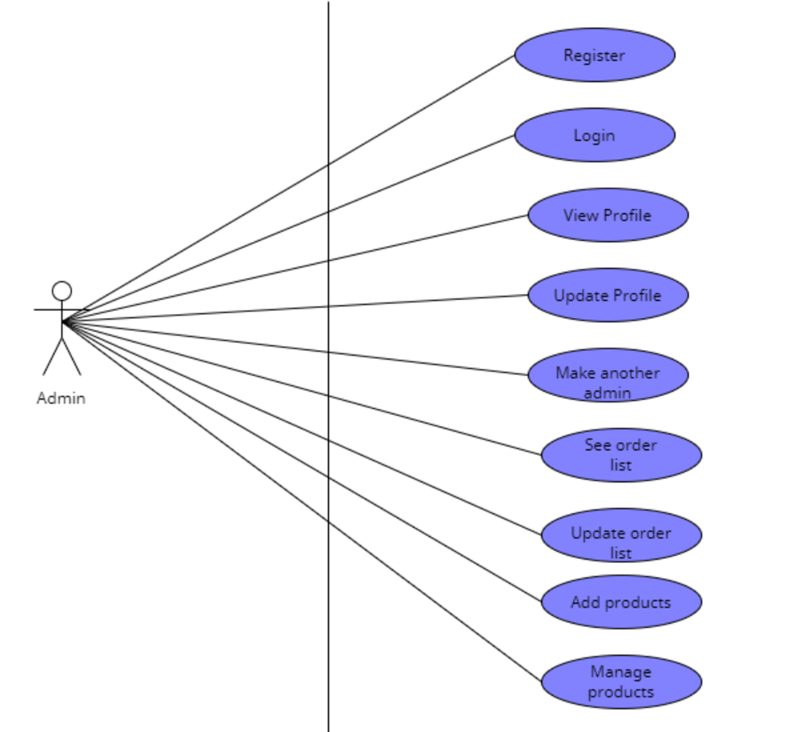

The functionality of an admin is as follows:

The Admin shall be able to login using by filling up the email and password field  
The Admin shall be able to able to create a new admin by inputting his email  
The Admin shall be able to view orders made by a customer   
The Admin shall be able to change the status of an order using a dropdown  
The Admin shall be able to add a new product by inputting the product details in a form  
The Admin shall be able to delete products by clicking the delete button on a product

#### 3.2.2 Customer Functionality:

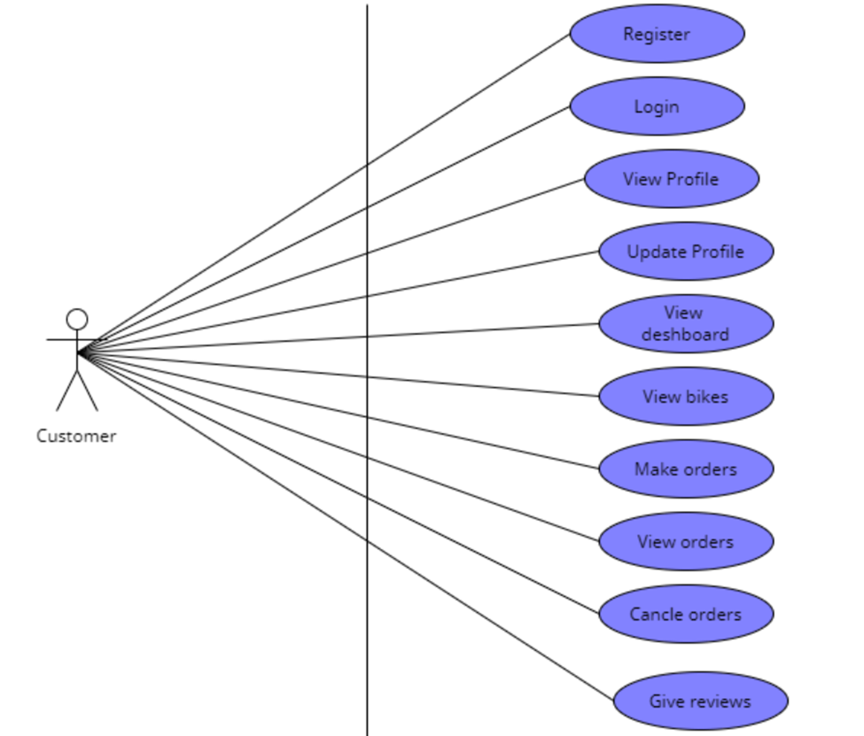

The function of Customer is such as:

The user shall be able to order a bike by filling out name phone and address input fields   
The User shall be able to change profile details by changing the text field and clicking on update   
The user shall be able to login using google login  
The user shall be able to register using email and password   
The user shall be able to view order status in his profile

## 3.3 Performance Requirements

Performance requirements are plays a vital role in any software, and its Software Requirements Specifications (SRS) document because it explains how the software works with its best outcomes. Bike Ecommerce Store software is a system that provides an automatic system or process that is used by a customer for ordering bikes at favorable prices. Here, the admin can track all details, changes details if he needs, and also modify prices or details, and so on. Every option is fully customizable admin or customer can choose whatever they want and even can modify also.

·       Customer can find all accurate details of his or her desire product.

·       No hassle for order.

·       System notify to the admin as well as customer also.

·       Wireless order system.

·       Eco friendly.

·       Admin can manage everything smoothly with proper instructions.

·       Automatic order and prices are calculated.

·       Customer shall not need to visit showroom.

·       Shall not need to go bank for transaction.

## 3.4 Logical Database Requirements

ER diagram of the database requirements is given below

#### Admin ER diagram:

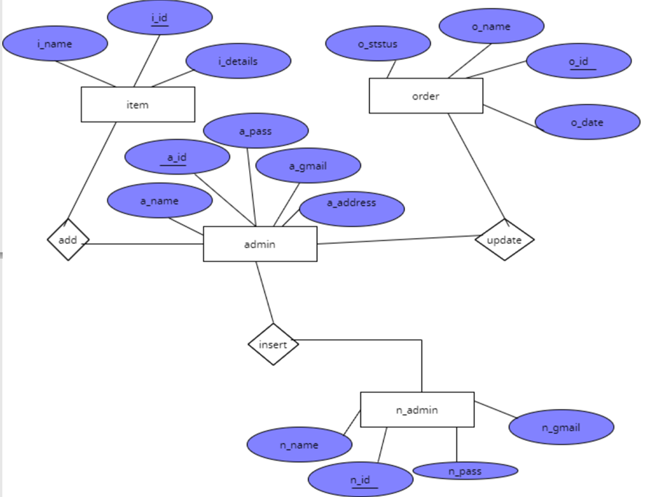

**Customer ER diagram**

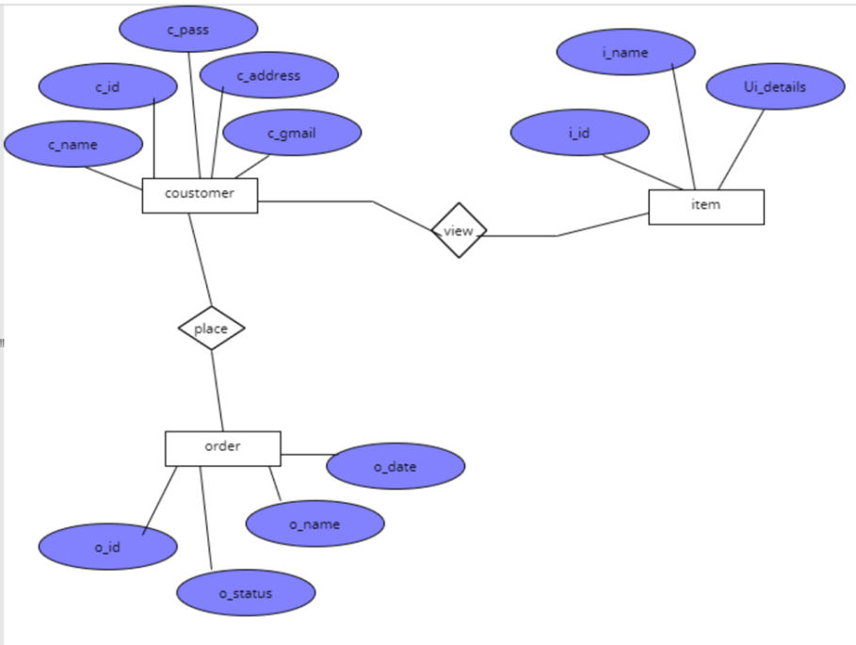

## 3.5 Design Constraints

Like other software Bikes Ecommerce Store have some design or other constraints also. Therefore some arrival design constraints are given below;

* Usages of outside regulation: Usually, the data passes from client to server through TCP/IP system or protocol but this software is not used any type of public-key encryption service such as Secure Sockets Layer (SSL) certificate. For this reason, this software has constraints to passing user data and causes for confidentiality, and integrity causes.
* Bandwidth limitations: This constraint may lose some server connection for a few technical mistakes (Sometimes depends on Hardware or Internet connection). For this cause, it needs to run the query afresh.
* Databases: JSON file is used in this software that user queries have more than servers’ limitations that it needs to observe and fresh table data or information. In this incident, there has a lack of DB caching.
* Communication protocols: For communication protocols, TCP/IP is used to interact with the server, and another protocol is not considered for user demand.
* Parallel operations: The parallel use of other internet applications with this software or project may hamper its bandwidth, and also may occur in the taking time for a query for slow connections.

### 

### 3.5.1 Standards Compliance

For the standards compliance, it may cause (In case of Internet Security):

**·       Confidentiality problem:** Here, sometimes the user, intended server fails “understanding” message contents and types.

**·       Integrity problem:** Hither, the sender, server may fail to ensure message not altered without detection.

**·       Authentication problem:** Server may not recognize/confirm actual valid user.

**·       Impersonation:** Can fake (spoof) source address in packet (or any field in packet).

**·       Denial of service:** Prevent service from being used by others (e.g., by overloading resources).

**·       Eavesdrop:** There may be Intercept messaging, actively insert messages into connection.

## 3.6 Software System Attributes

### 3.6.1 Reliability

Sometimes little third-party software is tried to use to build up this software or project. Therefore, these are free components; most of them are indicated as open source. This software has used a strong database component named JSON for protecting strongly, for this reason, this software will not affect by others. Moreover, this software is not used other things that indicate illegal, so it is the most reliable software to use frankly.

### 3.6.2 Availability

System’s availability requirements:

·       User must have basic knowledge how to use computer or smart phone.

·       Every device must have internet connection.

·       The user must know English language for operate device properly, as the user   interface will be provided in English.

·       Every device must have enough hardware resource for run the software.

### 3.6.3 Security

### System’s security requirements:

### ·       User authentication is required to access the system.

### ·       A client or user must be a registered user to login to use the features of the Bike Ecommerce Store.

### ·       Without proper authentication no one can login to the system or use the features.

### 3.6.4 Maintainability

OOP principles must be followed to make sure the system is maintainable and extendable.

### 3.6.5 Portability

The eCommerce site will run on a webserver and accessed by a browser. Thus as long as a machine can run a JS enabled browser it can access the system.

|  |  |  |  |  |  |  |  |  |  |  |  |  |  |  |
| --- | --- | --- | --- | --- | --- | --- | --- | --- | --- | --- | --- | --- | --- | --- |
| **ID** | **Characteristic** | **H/M/L** | **1** | **2** | **3** | **4** | **5** | **6** | **7** | **8** | **9** | **10** | **11** | **12** |
| 1 | Correctness |  | H |  |  |  |  |  |  |  |  |  |  |  |
| 2 | Efficiency |  | M | L |  |  |  |  |  |  |  |  |  |  |
| 3 | Flexibility |  | M | L | M |  |  |  |  |  |  |  |  |  |
| 4 | Integrity/Security |  | H | L | M | H |  |  |  |  |  |  |  |  |
| 5 | Interoperability |  | H | M | M | H |  |  |  |  |  |  |  |  |
| 6 | Maintainability |  | H | M | H | L |  |  |  |  |  |  |  |  |
| 7 | Portability |  | L | H | H | L |  |  |  |  |  |  |  |  |
| 8 | Reliability |  | H | H | H | M |  |  |  |  |  |  |  |  |
| 9 | Reusability |  | L | L | H | H |  |  |  |  |  |  |  |  |
| 10 | Testability |  | L | H | H | L |  |  |  |  |  |  |  |  |
| 11 | Usability |  | M | M | L | M |  |  |  |  |  |  |  |  |
| 12 | Availability |  | H | M | L | H |  |  |  |  |  |  |  |  |

## 

## 3.7 Organizing the Specific Requirements

The organizing the specific requirements potion is talking about the Bike Ecommerce Store organizing requirements and getting familiar with its best system or every function.

### 3.7.1 System Mode

**DeshBoard**

·       Can view Bikes advertisement.

·       Can order Bike.

·       Can view reviews.

·       Can find signup or sign in options.

·       Can trace contract.

·       Can know about this software.

·       Can subscribe.

**Admin**

**·** Can register.

·       Can login.

·       Can view profile.

·       Can update profile.

·       Can make another admin.

·       Can see order list.

·       Can update order list.

·       Can add products.

·       Can manage products.

**Customer**

**·** Can register.

·       Can login.

·       Can view profile.

·       Can update profile.

·       Can view dashboard.

·       Can view bikes.

·       Can make order.

·       Can view orders.

·       Can cancel orders.

·       Can give reviews.

### 3.7.2 User Class

There are two user classes. The customer who orders the bike and the admin.





### 

### 3.7.3 Objects

*Objects are real-world entities that have a counterpart within the system. Associated with each object is a set of attributes and functions. These functions are also called services, methods, or processes. Note that sets of objects may share attributes and services. These are grouped together as classes.*

### 3.7.4 Feature

**Admin**

**·** Can register.

·   Can login.

·   Can view profile.

·   Can update profile.

·   Can make another admin.

·   Can see order list.

·   Can update order list.

·   Can add products.

·   Can manage products.

**Customer**

**·** Can register.

·       Can login.

·       Can view profile.

·       Can update profile.

·       Can view dashboard.

·       Can view bikes.

·       Can make order.

·       Can view orders.

·       Can cancel orders.

  Can give reviews

### 3.7.5 Stimulus

In the stimulus part, one can say that the admin system or feature is one of the best-organized processes in the Bike Ecommerce Store software. Here, an admin can maintain his or her all systematic work by logging in with a valid id and password to the software or system. Moreover, the admin has several functions such as updating the profile, making another admin, adding new products, managing products, and most importantly working with the delivery system also. Therefore, admin is the heart of this software. For this reason, one can say that the work of the admin is more important in terms of stimulus.

### 3. 7.6 Response

This software or application will have a graphical user interface, where the registered users can use it from any browser and so it is browser independent.

·       The working modules:

1)    Admin(owner)

2)    Customer

·       The system will store the information of all registered users information, customer orders, and bike details, income of the software, place order information and accurate calculation.

·       As the admin, has to login to the system, it means there is an authenticated & secure login system and secure data transmission for all users.

### 3.7.7 Functional Hierarchy

The Bike Ecommerce Store software can make a functional hierarchy whenever they need extra employees as their requirements. But at present admin can make another admin if he or she wants and other things customers can add or create their ID by themselves.

## 3.8 Additional Comments

For the Bike Ecommerce Store, if any feature or employee add or remove then few options, function will be change. Therefore functional hierarchy will be effected and alternative also.

# Change Management Process

Change Management Process is a process that depends on system or software changes or additions. If the Bike Ecommerce Store changes its management process it will not hamper its performance and other things. It still capable,

·       To make satisfy the clients.

·       To consume time.

·       To finds brand new bikes.

·       To help reduce the usage of labour, as tasks such as having to take orders from customers is eliminated.

·       To less chances of data being lost or incorrect data entry.

·       To efficient, smooth and easy procedure of running a e-commerce site.

·       To make faster orders.

The admin (owner) can monitor the Bike Ecommerce Store easily from any location.

# Document Approvals

**LETTER OF APPROVAL**

11th June, 2022.

To,

MR. R

Associate Professor Computer science and engineering,

American International University of Bangladesh (AIUB)

Sir,

We have prepared the report on Software Requirements Specification of 'Bike E-commerce Store' for your approval. This report details the requirements we gathered for the project.

The primary purpose of this report is to summarize our findings from the work that we completed as our Software documentation and tools course project. This report includes the details of each step we followed to collect the requirements.

Sincerely Yours,

MD. REAZ UDDIN CHOWDHURY (21-92155-3)

UMMEY SOAIBA YEASMIN (21-92158-3)

AKIBUR RAHMAN AKIB (22-92573-2)

SHEULY AKTER (22-92609-2)

MD. RIFAT UZ ZAMAN (22-92610-2)

**Approved By: MR. R**

**MR.R**

**11-06-22**

# Supporting Information

*The supporting information makes the SRS easier to use. It includes:*

1. *Table of Contents*
2. *Index*
3. *Appendices*

*The Appendices are not always considered part of the actual requirements specification and are not always necessary. They may include:*

*(a) Sample I/O formats, descriptions of cost analysis studies, results of user surveys*

*(b) Supporting or background information that can help the readers of the SRS*

*(c) A description of the problems to be solved by the software*

*(d) Special packaging instructions for the code and the media to meet security, export, initial loading, or other requirements*

*When Appendices are included, the SRS should explicitly state whether or not the Appendices are to be considered part of the requirements.*

Tables on the following pages provide alternate ways to structure section 3 on the specific requirements. You should pick the best one of these to organize section 3 requirements.

**Software Design Document**

1. **INTRODUCTION**

**1.1 Purpose**

This document is intended for all the stakeholders of the system especially for the development team so that everyone is on the same page and clear visualization about the requirements of the system before development can start. SDD gives a clear visualization to the user end as well as developer end. The requirements should reduce ambiguity as much as possible for the project to be successful. The stakeholders include the product owner, the various users, the project manager, the software engineers and designers. By using this user can easily make understand the concept to the developer.

**1.2 Scope**

This software design document is intended for all the stakeholders but primarily for the development. team of the system so that everyone is on the same page and clear about the designs of the system before development can start. The design documents should reduce ambiguity as much as possible for the project to be successful. The stakeholders include the product owner, the various users, the project

manager, the software engineers and designers.

The E-commerce store will have two user classes

1. Customers
2. Admin

The customer will be able to browse through the different bikes, login/register and order a bike that he likes

The admin will be able to login, manage the different product information, view and manage the orders and create other admins accounts.  
  
The system will allow users to quickly and easily view the technical specifications of each bike and make a purchase in the comforts of their home. They don’t need to go to a show room to view and buy the bikes. This saves the customer time and the owner of the system to serve more customers without hiring more sales reps.

The Ecommerce platform will have an API and a react based frontend which will consume the API and provide functionality to the software.

**1.3 Overview**

This SDD document is divided primarily into 6 parts. First part Introduction provides an overall functional requirement of the system written in consultation with the owner of the system. This section provides a overview of the users, how the system will be used by the various stakeholders and any constraints of the system.

The other parts outlines the system architecture and data design. This section will primarily be used by the development team which includes designers, developers and testers to build the final version of the system. It also show the visualization of component design and human interface design. And finally ended with the requirement matrix.

**1.4 Reference Material**

1. https://reactjs.org/
2. <https://www.mongodb.com/>
3. <https://sendgrid.com/solutions/email-api/>  
   <https://www.sendinblue.com/api/>
4. <https://www.twilio.com/docs/sms/api>  
   <https://rapidapi.com/blog/sms-apis-send-texts/>.

**1.5 Definitions and Acronyms**

1. API- API stands for Application Programming Interface
2. React- A JavaScript library for building user interfaces
3. NodeJs A JavaScript library for building user interfaces
4. MongoDb – Schema less database
5. **SYSTEM OVERVIEW**

**Product Perspective:**

The software product is standalone cloud-based software which will be accessible via web

browsers. Dependencies include the SMS API used for OTP during registration and login and

email API used to send marketing and other confirmation emails.

**System Interfaces:**

The system must integrate with a third part SMS API to provide OTP and other SMS

notification to the users. Some of the options for an SMS API is given below

https://www.twilio.com/docs/sms/api

<https://rapidapi.com/blog/sms-apis-send-texts/>

The system should also integrate with an email API to send invoices and other email

notifications to the users. So third part Email APIs answer given below

https://sendgrid.com/solutions/email-api/

https://www.sendinblue.com/api/

**Interfaces:**

The software application will be a cloud-based platform where the customers will access a

frontend application using a web or mobile browser and the admin will also be able to

access the backend dashboard using a browser

**Hardware Interfaces:**

The users of the system can use any JavaScript enabled modern browser on a mobile or

desktop device to access the web based application. No other specific hardware interfaces are

required. A minimum of 1 GB RAM on the hardware device is recommended for smooth

performance.

**Software Interfaces:**

The customer currently does not have any software that needs to be interfaced with. So the

system will be standalone API and a frontend interface. We only have to interact with the

third-party email and SMS APIs to provide SMS and email functionality

**Communications Interfaces:**

Our web application will interface with the backend REST API using the standard TCP/IP

over the internet. A basic overview of TCP/IP is linked below

<https://www.fortinet.com/resources/cyberglossary/tcp-ip>

**Memory Constraints:**

To make sure the application is accessible to as many customers as possible the devices with

low end RAM and processor should be able to smoothly run the application using a browser

without any performance issues. Based on our focus groups the RAM requirements are 1 GB.

**Operations:**

The typical operations of the bike ecommerce include inventory management and keeping

track of the model and number of bikes currently in stock. When a new bike included in

stock the admin will add the bike from the backend portal so that the new bike is visible to

the users. When a customer orders a bike, the admin will view the order and will change the

status of the order accordingly. There will be no payment gateway in the ecommerce store so

all the orders will have cash on delivery by default.

**Site Adaptation Requirements:**

Admins should have a decent laptop with at least 4 GB RAM 3 GHz processor to operate the

backend portal of the system. The Admin laptops should also have continuous electricity and

a stable internet connection.

**Product Functions:**

**Customers**

1. Customers can Login
2. Customers can Register
3. Customers can Make orders
4. Customers can View their Orders
5. Customers can Cancel their order
6. Customers can Give reviews

**Admin**

1. Admin Can Login
2. Admin Can Register
3. Admin Can Manage Products
4. Admin Can Add Products
5. Admin Can make a user an admin
6. Admin Can manage Orders
7. Admin Can view profile

**User Characteristics:**

The primary users are customers who will access the system online. Users have minimal

technical knowledge about bikes and hence need intuitive navigation aids and simple page

layouts.

Administrator is responsible for maintaining the system and will be involved in software

fixes, deployment and regular maintenance.

**Admin Use Case**



**Customer Use Case**



1. **SYSTEM ARCHITECTURE**

**3.1 Architectural Design**

The primary backbone of the web app is a nodejs based REST API which will be responsible to fetch and serve data to both the frontend app and the database server.

Two other third party APIs will be used to send SMS and email notifications

The front end will be a separate app built using a javascript library called React. React is a very flexible library that can generate static sites with dynamic data. This will allow the site to be very responsive and have very low load times which are necessary for a high converting ecommerce store

A class diagram is provide below to demonstrate how each component of the application will interact with each other



**3.2 Decomposition Description**

The customer will order a bike after viewing and signing into the platform. A flow diagram for the customer is provided below

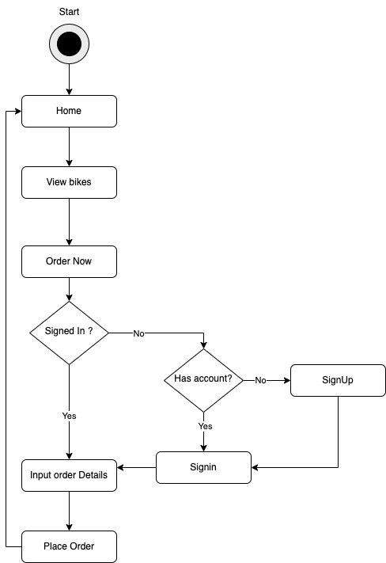

**3.3 Design Rationale**

REST API based architecture using NodeJs will allow very fast read/write operations. As it is well know node servers are not very good at cupute heavy tasks but are very good at fast read and write operations.

As an ecommerce store the web application will need to handle a lot of read and write requests but they wont be very copute heavy. So Node JS is used as the web server

React is used for the frontend for its

1. **DATA DESIGN**

**4.1 Data Description**

Though we are using MongoDB which is a schema less database we will still need a database structure which will map into an ORM so that it will be easier for the development to follow the database structure. The ER diagram of the system is given bellow



* 1. **Data Dictionary**

The data dictionary contains the datatype of each attribute based on the Entity Relation diagram and the keys that correspond to the relationship to it.

|  |  |  |  |
| --- | --- | --- | --- |
| **Entity** | **Attribute** | **Datatype** | **Key** |
| Customer | Id | Int(32) | Primary Key |
|  | Name | Varchar(256) |  |
|  | Phone | Varchar(256) |  |
|  | password | Varchar(256) |  |
|  | email | Varchar(256) |  |
| Admin | Id | Int(32) | Primary Key |
|  | Name | Varchar(256) |  |
|  | Email | Varchar(256) |  |
|  | Password | Varchar(256) |  |
|  | Phone | Varchar(256) |  |
| Product | Id | Int(32) | Primary Key |
|  | Name | Varchar(256) |  |
|  | Price | double |  |
|  | Description | Varchar(256) |  |
|  | ImageUrl | Varchar(256) |  |
| Order | Id | Int(32) | Primary Key |
|  | Status | Varchar(256) |  |
|  | Items | Array(100) |  |
|  | customerID | Int(32) | Foreign Key |

1. **HUMAN INTERFACE DESIGN**

**6.1 Overview of User Interface**

Describe the functionality of the system from the user’s perspective. Explain how the user will be able to use your system to complete all the expected features and the feedback information that will be displayed for the user.

**6.2 Screen Images**

# UI Wireframe

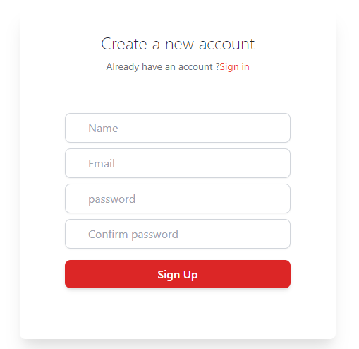

**Login interface**

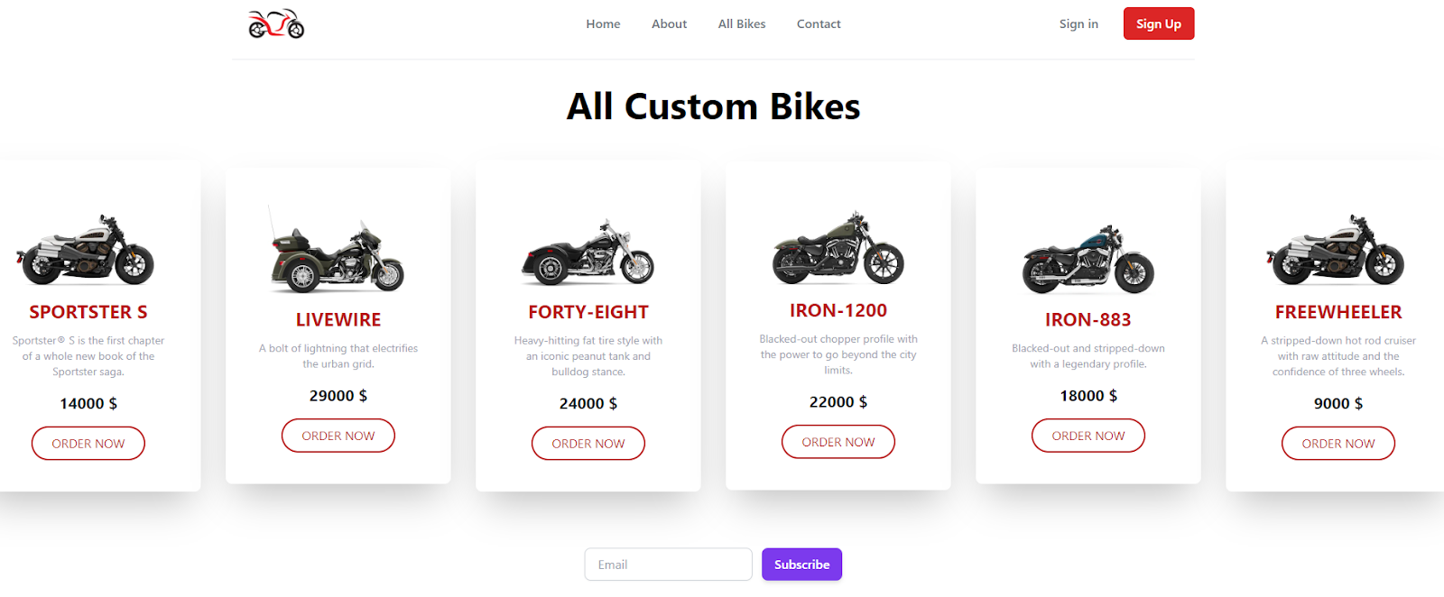

**View All Product**

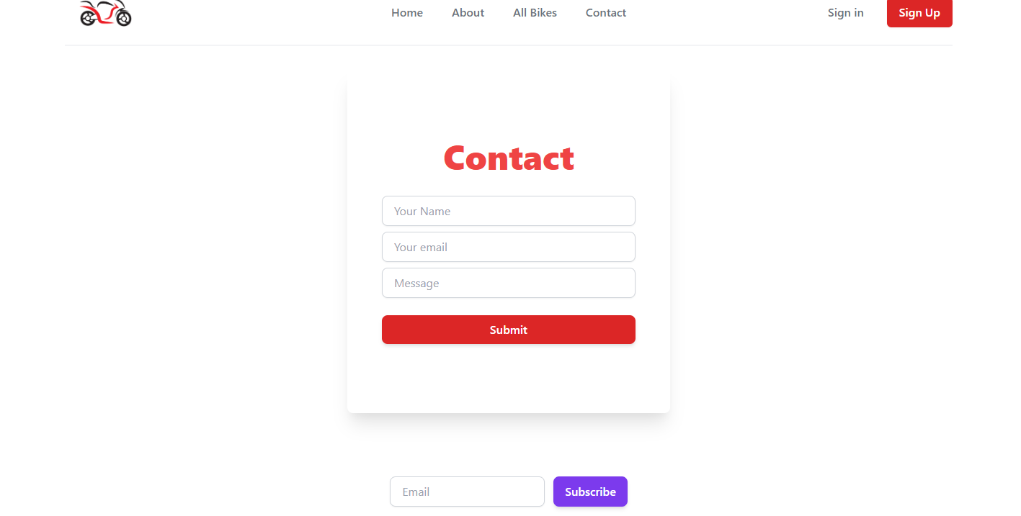

**Contact Page**

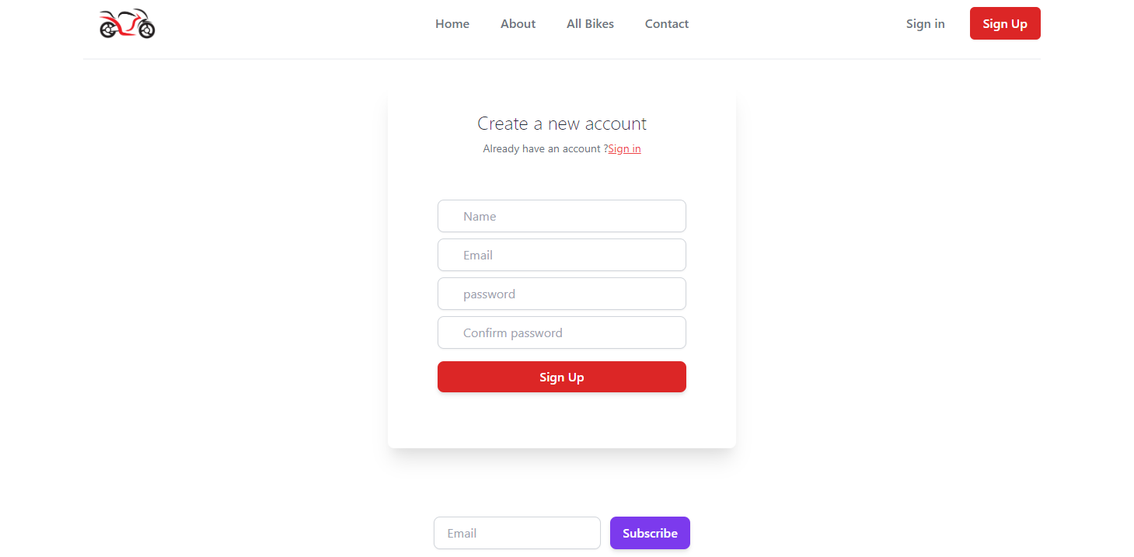

**Sign up page**

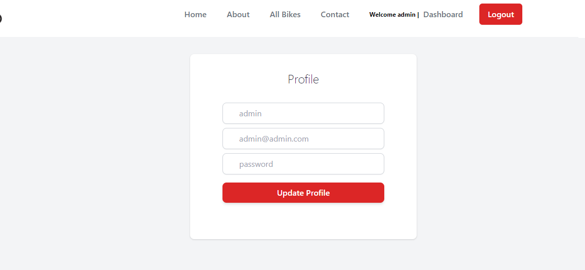

**update profile page**

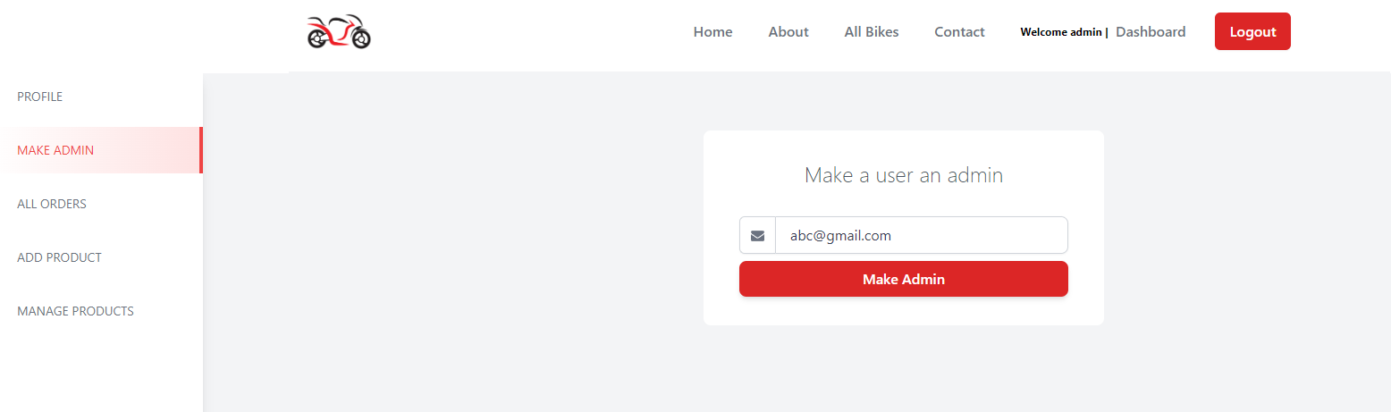

**Add user as admin**

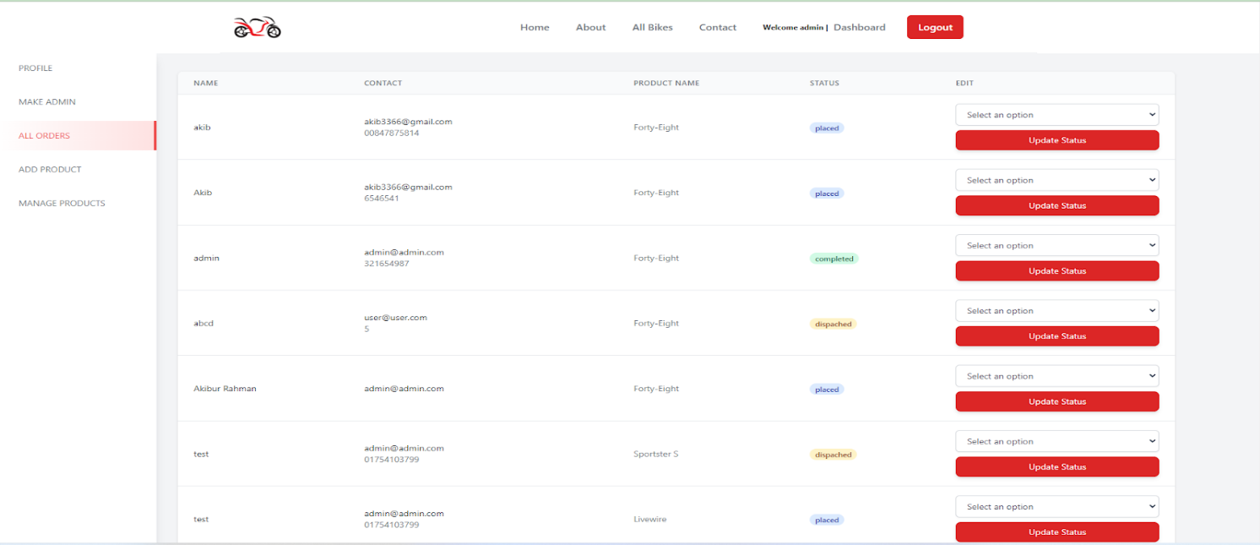

**Admin can manage order**

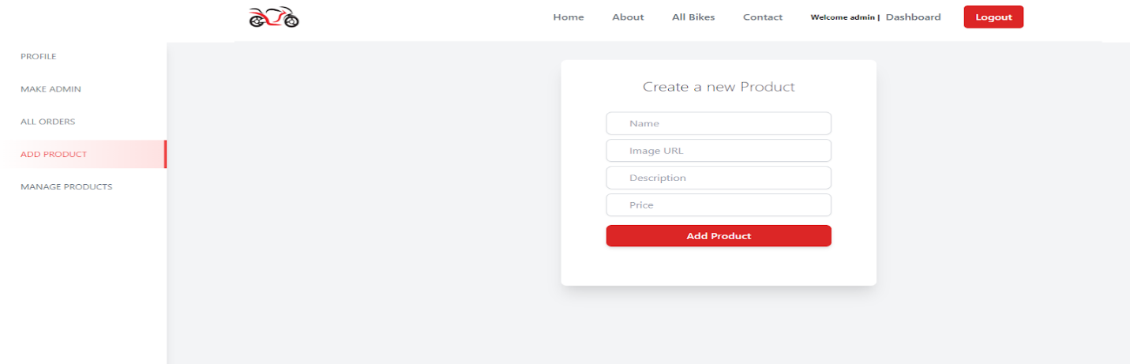

**Add product**

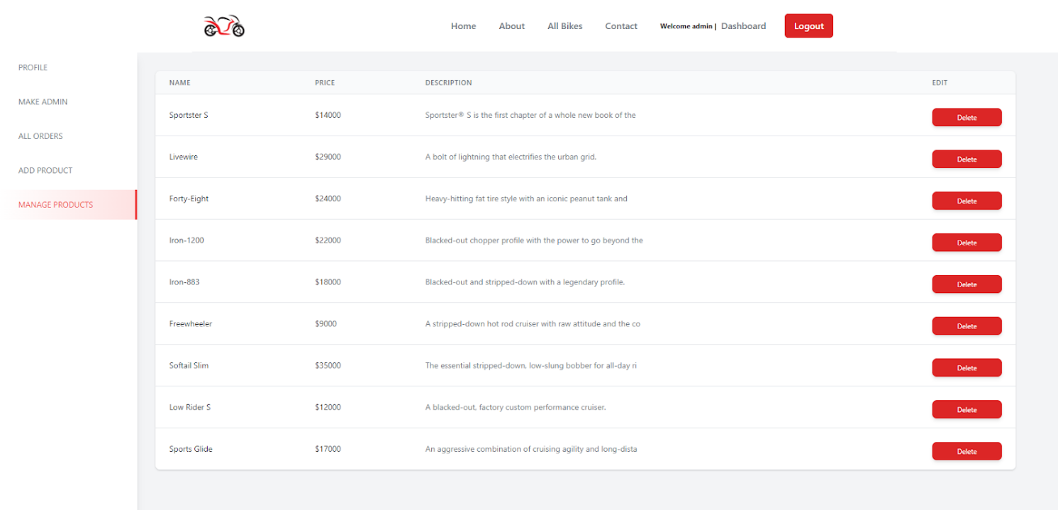

**Manage product**

**Testing**

# 1   INTRODUCTION

## 1.1 PURPOSE OF THE TEST PLAN DOCUMENT

The Test Plan documents and tracks the necessary information required to effectively define the approach to be used in the testing of the project’s product. The Test Plan document is created during the Planning Phase of the project. Its intended audience is the project manager, project team, and testing team. Some portions of this document may on occasion be shared with the client/user and other stakeholders whose input/approval into the testing process is needed.

# 2   FUNCTIONAL TESTING

## 2.1 TEST RISKS / ISSUES

Based on the framework, the testers can easily execute the tests and obtain relevant     results by generating test reports. But selecting the right tool to automate Website depends on many key parameters.  It is always important to compare the available tools based on key parameters like features, performance, extensibility, licensing cost, maintenance cost, and Training and support. Continuous changes for demands Regression so run regression test suits every day to keep track of the effects of change.

**2.2** **ITEMS TO BE TESTED / NOT TESTED**

|  |  |  |  |
| --- | --- | --- | --- |
| **Item to Test** | **Test Description** | **Test Date** | **Responsibility** |
| Customer Register | OTP will be sent to the given mobile number and the account | 1/7/2022 | Successfully done |
| Customer log in | After successfully login by using user Id, password and can view dashboard | 1/7/2022 | Successfully done |
| Customer view profile | System shows all given information in a tabular form with all details that saved | 4/7/2022 | Fail, go to developers |
| Customer update profile | Change information is accepted and gives notification | 7/7/2022 | Successfully done |
| Customer view dashboard | Able to see their desire or wanted bikes with proper details from the site | 10/7/2022 | Successfully done |
| Customer make order | Capable to make order without any types of hassle and as well as can get notification | 13/7/2022 | Successfully done |
| Customer view order | Place order will be shown and recorded by a tabular form with date, time, and place | 15/7/2022 | Fail, go to developers |
| Customer cancel order | The new order can be done by the customer and get notification | 17/7/2022 | Successfully done |
| Customer give review | Reviews will be stored by a tabular form and after submitting that admin can monitor those reviews | 19/7/2022 | Successfully done |
| Admin register | OTP will be sent to the given mail or mobile number and also confirm the account | 21/7/2022 | Successfully done |
| Admin login | By given correct user Id and password, Admin can login to the site that is stored into the site storage | 22/7/2022 | Successfully done |
| Admin view profile | Given all information will be visible to admin those stored into the database | 23/7/2022 | Successfully done |
| Admin update profile | System update the profile and sends notification to assign mobile number or mail Id and saves details | 23/7/2022 | Successfully done |
| Admin make admin | System saves new admin details and sends notifications both admin | 25/7/2022 | Successfully done |
| Admin see order | Given entire order store to the database and sends all details to admin | 27/7/2022 | Fail, go to developers |
| Admin update order | Admin can update place order list whenever he needs and sends notification to both customer and admin | 29/7/2022 | Successfully done |
| Admin add product | Newly products will be added by admin and saves details to the database as well as shown dashboard | 31/7/2022 | Successfully done |
| Admin manage product | Admin will be able to manage products that save to site database and shows details in a tabular form | 2/8/2022 | Successfully done |

## 2.3 TEST APPROACH(S)

A website/application works differently for different user profiles such as customers (both authorized and unauthorized), sales representatives, and online shop managers. It is, therefore, important to make sure that your website test cases cover the varied operations for all types of users such as filtering of items, adding/removing goods to the shopping cart, and so on. To offer a hassle-free experience to customers, it is pivotal to test the complete workflow of your web/mobile application that consists of login and signup options, sorting feature, search functionality, add/remove functionality in the shopping cart, check-out process, payment gateway, and payment processing among others. An increasing number of users are now using mobile devices, driving companies to reconsider their testing strategy, and take a mobile-first approach in their applications. The important aspect here is to test the responsive design of the application in mobile devices of different screen sizes.

## 2.4 TEST REGULATORY / MANDATE CRITERIA

Test regulatory changes when there is a disconnect between regulatory adherence and product development. This disconnect happens when regulations are tracked by different teams, and in different systems than those used to track requirements and testing on the product side. Sometimes it’s because of an institutional gap those on the product team simply aren’t regulatory experts, and vice versa. Other times it is a tool gap, where regulations can’t be tracked within the same tool as these other processes.

## 2.5 TEST PASS / FAIL CRITERIA

In 18 items that we have tasted,15 items will done successfully and 3 items become fail then it returns to the developers for solve

## 2.6 TEST ENTRY / EXIT CRITERIA

 The testing entry criteria are the Customer Register so that customers can login into the system will be sent to the given mobile number and will be confirmed by the account.

The testing exit criteria is Admin manage product that admin can manage products such as its price, details, stock and so on.

## 2.7 TEST DELIVERABLES

A record of the consequences of the take a look at the side of maps and graphs displaying CPU operation, reminiscence operation and database connections used over the length of the take a look at.

## 2.8 TEST SUSPENSION / RESUMPTION CRITERIA

Issue due to which suspension occurs gets resolved. Software resources are available as per the requirements. Output meets the expected. No further defect has been found in the resumption technique

## 2.9 TEST ENVIRONMENTAL / STAFFING / TRAINING NEEDS

Test might be finished on the image of the stay server in order that the stay utility isn`t

 affected. A tester will use automation equipment to simulate one thousand customers appearing preferred responsibilities at the utility like registering, login, ordering and so on

# 3   LOAD TESTING

## 3.1 TEST RISKS / ISSUES

Load testing will be done on the frontend react app and on the API endpoints. We need to make sure that we don't do it on a live server after deployment as this can cause performance issues for users.

## 3.2 ITEMS TO BE TESTED / NOT TESTED

|  |  |  |  |
| --- | --- | --- | --- |
| **Item to Test** | **Test Description** | **Test Date** | **Responsibility** |
| API | API will be tested to check ability to serve 1000 users simultaneously | 3/7/22 | Tester |
| React Front end | Check responsiveness of the react app under 1000 user load | 3/7/22 | Tester |

## 3.3 TEST APPROACH(S)

Load testing will be done system-wide to test the API and frontend app simultaneously. The main objective of the test will be to test the stability and responsiveness of the system under a large load. Automation tool will be used to simulate users using the system.

**3.4** **TEST REGULATORY / MANDATE CRITERIA**

System must be responsive even when a thousand users are using it simultaneously.

## 3.5 TEST PASS / FAIL CRITERIA

Test will pass if the system remains responsive when a thousand users are using the

System for 10 minutes. Test will fail if the system becomes unresponsive

## 3.6 TEST ENTRY / EXIT CRITERIA

**Entry Criteria:** Test automation tool will simulate 1000 users and start performing    different actions on the system.

**Exit Criteria:** If the system remains responsive for 10 minutes or if the system   becomes unresponsive

## 3.7 TEST DELIVERABLES

A report on the results of the test along with charts and graphs showing CPU usage, memory usage and database connections used over the period of the test.

## 3.8 TEST ENVIRONMENTAL / STAFFING / TRAINING NEEDS

Test will be performed on a clone of the live server so that the live application isn't   affected. A tester will use automation tools to simulate 1000 users performing standard tasks on the application like registering, login, ordering etc.

**4**   **UNIT TESTING**

For Bike Ecommerce Store, unit tests will be avail to develop for testing all interfaces of this software or site all of the components on the side the low-level unit tests will be suitable to develop by testing methods of the initial classes in the components. Therefore, as a prerequisite of this software or site, the automatic unit test suite is to run by building server on a prebuild basis options. Mainly, the unit testing of software testing indicates a method that works on every individual units of source code of the software (which sets of one or more software modules with associated control data, usage of procedures, and operating procedures) are tested to determine that suitable for an application or user. Moreover, the white-box testing method is used in Unit testing and it is generally done by the programmer.

**4.1**  **TEST RISKS / ISSUES**

**For Customer:**

**Registration:**

For customer registration tests risks or issues can be occurred when the tester gives any invalid information for new registration and oversight typing of code by a developer. After that low network connections, misunderstanding any option, and not storing all information properly in the database can be causes of these test risks.

**Login:**

Typing mistake of pre-registered user id or password is the major test risk or issue for the login page or feature. Moreover, the server connections, false program typing, and storing data problems are also other possible test risks or issues.

**View Profile:**

Storing duplicate data that customer gives during the registration will be the main indicated issue that will occur hassle for the customer. Lacking database functionality, and programming, not giving the right information will be shown as a problem.

**Update Profile:**

Not giving modern or new information to the customer properly, and retype the previous one while the customer wants to update the profile this issue will be found. At the same time, the storage capacity of this site or software or network connection, and mistaking compose of code will be found as a test risk or issue of update profile.

**View Dashboard:**

After successfully registration and login dashboard is found but the cause of invalid login or registration, network issue, and faux enter of codding by developer the view dashboard issue will be shown.

**Make Order:**

To buy bikes, sometimes whole details not shown properly or will not take order for network issue, and error entry of programming.

**View Order:**

Not storing order details into the database for complex network issue and lacking of codding, view order will create test issues.

**Cancel Order:**

After conforming order, sometime customer cannot cancel order because of expired date and server problem at the same time codding functionality also causes of test issues.

**Give Review:**

Could not store review in a tabular form cause of functional complexity and server maintaining at the same time submitting button sometime not working, those indicates the test risk or issues of this software or site.

**For Admin:**

**Registration:**

For admin registration tests risks or issues can be occurred when the tester gives any invalid information for new registration, used pre-defined name or information and oversight typing of code by a developer. After that low network connections, misunderstanding any option, and not storing all information properly in the database can be causes of these test risks. Must have ensure about admin registration form is correct.

**Login:**

Typing mistake of admin login pre-registered user id or password is the major test risk or issue for the login page or feature. Additionally, the server connections, false program typing, and storing data problems are also other possible test risks or issues.

**View Profile:**

Storing duplicate data that admin gives during the registration will be the main indicated issue that will occur hassle for the customer. Lacking database functionality, and programming, not giving the right information will be shown as a problem.

**Update Profile:**

Not giving modern or new information to the customer properly, and retype the previous one while the customer wants to update the profile this issue will be found. At the same time, the storage capacity of this site or software or network connection, and mistaking compose of code will be found as a test risk or issue of update profile.

**Make Another Admin:**

Making another admin, the person must be admin and full fill all requirements that store information and notify both admin but cause of sufficient storing capacity it creates problem and also misunderstanding of system requirements and error codding is also cause of this test risk.

**View Order list:**

Lacking capacity of the database storing of order list, submitting button issues, and server problem will indicates view test issue or risk.

**Update Order list:**

Sometimes cause of network or server cause, mistake of programming, and time limitation can be cause of update order list test issue.

**Add New Products:**

Not avail to storing details of adding new products into the database and functional complexity creates test issue as well as matching older products information creates test issues.

**Manage Products:**

Misunderstanding of system requirements, change request for the system, and matching older version of product with the newer versions or products with complex codding or functionality of the system is causes of this test risk.

**4.2**  **ITEMS TO BE TESTED / NOT TESTED**

**For Customer:**

|  |  |  |  |
| --- | --- | --- | --- |
| **Item to Test** | **Test Description** | **Test Date** | **Responsibility** |
| Registration | Must full fill all valid information and must sent OTP to assign number for confirming account. | 22/06/2022 | Successfully done with outstanding outcome |
| Login | Using valid user id and password avail to see dashboard | 22/06/2022 | Successfully done with outstanding outcome |
| View Profile | Can avail to see their given information in a tabular form that saves into the database | 24/06/2022 | Some error detected and go to the developers again |
| Update Profile | Changing details accepted, saves into the database and gives notification | 26/06/2022 | Some error detected and go to the developers again |
| View Dashboard | Can able to view and scroll bikes details from the system | 26/06/2022 | Successfully done with outstanding outcome |
| Make Order | Without any hassle, capable to make order and also get notify | 27/06/2022 | Successfully done with outstanding outcome |
| View Order | Avail to see place order with exact time, date, place by storing a tabular form | 29/06/2022 | Successfully done with outstanding outcome |
| Cancel Order | New order will be accepted and get notify | 29/06/2022 | Some error detected and go to the developers again |
| Give Review | Submitting reviews store by a tabular form and admin monitor or get notify | 1/07/2022 | Successfully done with outstanding outcome |

**For Admin:**

|  |  |  |  |
| --- | --- | --- | --- |
| **Item to Test** | **Test Description** | **Test Date** | **Responsibility** |
| Registration | Full filling valid information and OTP sent to assign number for confirming account. | 1/07/2022 | Successfully done with outstanding outcome |
| Login | Giving valid user id and password avail to see dashboard | 2/07/2022 | Some error detected and go to the developers again |
| View Profile | Avail to see given information in a tabular form that saves into the database | 4/07/2022 | Successfully done with outstanding outcome |
| Update Profile | Newer details accepted, saves into the database and gives notification | 7/07/2022 | Successfully done with outstanding outcome |
| Make Another Admin | Capable to save new admin information and get notify both admin | 8/07/2022 | Some error detected and go to the developers again |
| View Order list | Receiving order saves into the database with all details | 10/07/2022 | Successfully done with outstanding outcome |
| Update Order list | Capable to change place order list and notify both admin and customer | 13/07/2022 | Some error detected and go to the developers again |
| Add New Products | Adding newly products saves into the database and shown into the dashboard | 15/07/2022 | Successfully done with outstanding outcome |
| Manage Products | With whole details managing products saves to database by a tabular form and avail to see those into the site | 18/07/2022 | Successfully done with outstanding outcome |

**4.3**  **TEST APPROACH(S)**

Software testing is the process of analyzing software to find the difference between the required and existing condition. Software testing is done throughout the software development life cycle and also to create quality software, for this purpose two basic testing approaches are used which are white box testing and black box testing. . We plan specification-based testing approaches by developing a wide variety of implementation-based testing techniques to be applicable to formal specification languages.

The Following section will be about Testing Levels:

**System Testing:**

When we get to the system tests, we should have completed the unit and integration tests and has the software fully loaded in a test environment. The main purpose of system testing is to evaluate

The system meets the specified requirements. The black box test method is used in system testing. System testing should be done by a professional tester.

In our Bike Ecommerce Store system, we focus on the following:

* **Usability testing**: The user interfaces of the system are easy to use and easy to understand or not.
* **Documentation test** - When the customer uses the system, the system guide explains the functions as they work in real life. We will check it.
* **Functionality test**: As described in the documentation, the system behaves as expected or not.
* **Interoperability test**: Check that the system works with different operating systems, browsers, plugins, etc. Properly or not.
* **Performance Test** - Performance Test is the most important test for our Ecommerce system. We need to verify that our system can meet the requirements for speed, responsiveness, and stability under load. And it will help ensure a more positive user experience.
* **Security testing**: Our System can check testing validation (the input and output like **User’s Name, User’s Password**) or not.

**4.4**  **TEST REGULATORY / MANDATE CRITERIA**

Here, the Bike Ecommerce Store system will be a more efficient and error-free application by regularly testing and mandate criteria. With the help of regularly testing, we can easily detect errors, verify data flow and properly control flow tests, give an idea of how it looks on the web platform. We can also complete our project within budget and on time. Regularly testing tests provide a visual representation of a project.

The Following section will be about Testing Regulatory or Mandate Criteria Levels:

**Selenium**:

Selenium (Automated Cross-Browser Regression Testing) is free and open source. It has many high-end spin-offs, such as Sauce Labs, that rely on code to provide additional functionality. The tools created in this context are essential for testing browser compatibility.

**Postman**:

Tests are regularly checked by creating test suites that can be run over and over again. Postman can be used to regularly many types of tests, including unit tests, functional tests, integration tests, end-to-end tests, regression tests, mock tests, and more. Regularly testing prevents human error and streamlines testing.

**Cloud Bees**:

Fully regularly test suite from code to production. Cloud Bees includes unit testing and continuous integration features, and it gets started for free. Used by database.

**CircleCI:**

CircleCI(continuous integration platform. Used by Facebook and Spotify) provides a comprehensive platform for regularly testing, among other things, as its own build environment and deployment tools.

**4.5**  **TEST PASS / FAIL CRITERIA**

This section is for Pass and Fail criteria. Pass and Fail criteria is mandatory in the Test Design specification. As we know when the system requirement matches the all requirement the test is considered as pass and when failure to meet requirement the test is considered as fail.

Here when components matches with the dedicated interfaces design then it will considered as pass. In testing time if component failure to meet the objectives of the object design specification, it will fail. Here Integration criteria pass when the interface environment team give a positive result after test and it is failed when failure to meet the objectives of both the object design specification and the system architecture specification. A system test pass or fail declared after doing functional requirements, non-functional requirements and use cases as an oracle test. A defect/issue will be reported in the defect tracking system for review by the triage team.

Additionally, there have some Pass/Fail criteria for this system:

* **Component Pass/Fail criteria:** The tests executed on components only pass when they pacify the signatures, constraints & interfaces. This includes positive tests, negative, boundary tests & stress test. If a test exhibition a product failure to meet the objectives of the object design specification, it will fail & a defect or issue will be reported in the flaw tracking system for analysis by the team.
* **Integration Pass/Fail criteria:** The tests executed on combined components only pass when they satisfy the signatures, constraints & interfaces dictated by both the object design & the system architecture specification. This includes positive tests, negative test, stress tests that explicitly operate the interface atmosphere such as the physical connection to the database server.
* **System** **Pass/Fail criteria:** The tests executed against the system use the use cases, functional requirements & the nonfunctional requirements as the oracle to detect pass or fail. If a test exhibition failure to meet the objectives of any of the functional requirements or any non-functional requirements, it will fail & a defect problem will be informed in the defect tracking system for review by the team.

**4.6**  **TEST ENTRY / EXIT CRITERIA**

Into the whole software total 18 feature have that where we have tasted every features,12 features will done successfully by giving outstanding result and 6 features become fail with some error then it return to the developers for solve then it will be tested again.

**For Customer:**

**Entry Criteria:** Must have to register them as a customer to enter the system with valid information and give right user id and password for login to the site.

**Exit Criteria:** When customer login the site and not working till 10 minutes the system automatically exit the customer from the site and customer have to again login to the software.

**For Admin:**

**Entry Criteria:** Must have to register as an admin to enter the system with valid information and give right user id and password for login to the site.   
  
**Exit Criteria:** If admin login the site and not working till 10 minutes the system automatically exit the customer from the site and admin have to again login to the software.

**4.7**  **TEST DELIVERABLES**

Our IT teams has responsibility for the following software testing deliverables and milestones

**Phase: 1 Testing Deliverables:**

|  |  |
| --- | --- |
| Items Name | Date |
| Master Test Plan | May 2022 |
| System Test Results Document | June 2022 |
| Acceptance Test Results Document | July 2022 |

**Phase: 2 Testing Deliverables:**

|  |  |
| --- | --- |
| Items Name | Date |
| System Test Results Document | July 2022 |
| Acceptance Test Results Document | August 2022 |

**4.8**  **TEST SUSPENSION / RESUMPTION CRITERIA**

**Test Suspension / Resumption Criteria: Test Suspension** is a suspending the complete or part of the testing activities where **Resumption Criteria** imply resuming the previously suspended activities.

Some possible reason for suspension of the test:

* Unavailability of external dependent systems during execution.
* When a defect is introduced that cannot allow any further testing.
* Critical ordering or place order deadline is missed so that the client will not accept delivery or order even if all testing is completed.
* A specific holiday shuts down both development and testing.

And the test will be resumes when meet the requirement again:

* When the external dependent systems become available again.
* When a fix is successfully implemented and the Testing Team is notified to continue testing.
* The contract is renegotiated with the client to extend delivery.
* The holiday period ends.

**4.9**  **TEST ENVIRONMENTAL / STAFFING / TRAINING NEEDS**

One separate, controlled system will be required for the initial phase of testing, setup as per one standard, complete office environment. In order to maintain the integrity of the test environment his network will not be accessible to anybody outside this project. The printers are also exclusively for use by the test network.

**Hardware components required**

* 1 Network Controller
* 6 Networked PC's (See below)
* 1 DAP Workstation
* 1 Oracle Server
* 1 HP LaserJet 4v Printer

**PC Specifications**

* The 6 PC's required for the test environment will include the following:
* 1 x P100, 1 GB SSD, and 16Mb RAM [Current Minimum Specification]
* 3 x P166, 1.5 GB SSD, and 32 Mb RAM [Current Standard Specification]
* 1 x P333, 2.5 GB SSD, and 64 Mb RAM [Current Maximum Specification]

These specifications are the various specifications currently in use in different branches. 1 x Pentium running Windows NT is also required as the Test center for controlling and executing the automated testing.

**Software required**

**Test Tool:** Selenium, postman for automated testing

**Server:** Oracle database server, MySQL Workbench, Install MySQL server and Apache server

**System:** Windows 10 professional with latest Microsoft 365 access.

**Network:** Setup a LAN gigabit and 1 internet line with a least 10 MB/s

**Staffing and Training Needs**

There will be at least one full time tester need to the project for the system and acceptance testing phases of the project. Staffing is fixed for the duration of this project.

**5**   **USER ACCEPTANCE TESTING**

**5.1** **TEST RISKS / ISSUES**

In software testing Risks are the possible problems that might endanger the objectives of the project stakeholders. It is the possibility of a negative or undesirable outcome. A risk is something that has not happened yet and it may never happen; it is a potential problem. In this project there have some ricks problem issue those are described below:

**For Customer:**

**Registration:** The first way to enter to this software is to do the registration. And for that there have some specified way to complete the registration. Test ricks in registration like there must have send the OTP in the mail. The mail account must include @gmail.com. Main ricks on it that if the Gmail is not correct then there is no alternative way to register in the system. There have some problems in OTP like sometimes there have some network issue for that reason OTP send in delay. Another test risks are that the given OTP will be send only in specified Gmail only.

**Login:** A user only can enter in the login if the registration is successful. After that using user id and password he/she can enter to the system. Ricks issue in login is that sometimes the user password is wrong and user tried several times then the I'd got blocked. So, there will be a solution that immediately the user can solve the forgetting password using that registered mail.

**View Profile:** Test issues in the user profile is sometimes some button may not work due to network issue. As the project is on-line based so when the network has some problem the system will automatically provide the notification.

**Update Profile:** Issues in update profile is that if the user mail given during the registration period is not same then user can't update profile. And during the update there will be send an OTP in the mail and for network issue sometimes it being late to deliver the OTP. Then the user face problem updating the profile.

**View Dashboard:** After placing order sometimes it need more time to adjust in the dashboard. After successful update it shows in the dashboard. And for this network issue user have to wait till the dashboard update.

**Make Order:** Due to bad network sometimes user face issue in placing order. They press order button but it may not work due to network issue. That time the user has to order it again from the system.

**View Order, Cancel Order:** To view order and cancel order have some technical issues like without giving the valid reason user can't cancel order and there need the admin approval. Sometimes admin is busy in some duty so that's why it delayed sometimes. And due to network issue user have some delay to browse the placed order.

**Give Review:** User can give review of product after successful delivered to the user. Something it need some time to update the delivery status for that user can't give review. So, issues in giving review user have to wait until the product shows delivered in the system.

**For Admin:**

**Registration:** For Admin registration the admin details is saved in the system automatically. And for that there have some specified way to complete the registration. Test ricks in registration is sometimes defined Id and Password may have some error like the mail account must include @gmail.com. Main ricks on it that if the Gmail is not correct then there is no alternative way to register in the system. There have some problems in OTP like sometimes there have some network issue for that reason OTP send in delay. Another test risks are that the given OTP will be send only in specified Gmail only.

**Login:** An admin only can enter in the login if the system has predefined admin id and password. After that using predefined admin id and password, he/she can enter to the system. Ricks issue in login is that sometimes the admin password is wrong and admin tried several times then the I'd got blocked. So, there will be a solution that immediately the admin can solve the forgetting password using that registered mail.

**View Profile:** Test issues in the admin view profile is sometimes some button may not work due to network issue. As the project is on-line based so when the network has some problem the system will automatically provide the notification.

**Update Profile:** Issues in update profile is that if the admin mail given during the registration period or the predefined time is not same then admin can't update profile. And during the update there will be send an OTP in the mail and for network issue sometimes it being late to deliver the OTP. Then the admin face problem updating the profile.

**Make Another Admin:** As admin information is predefined in the system so it is very difficult for a admin to create another admin. For that admin have to enter the predefined system to create another admin. And there have some technical ussies like admin have to be specified and have some network issues as well.

**View Order list, Update Order list:** To view order and update order have some technical issues like admin have to enter the order list and if there is some network issue the it will not enter. Sometimes system is busy in some updating issue so that's why it delayed sometimes. And due to network issue admin have some delay to browse the placed order.

**Add New Products, Manage Products:** Adding new product and manage them have issues like sometimes that specified product is not available or there have some stockout issue but due to bad network or because of system updating it have some delay and for that adding new product and manage product have some interruption.

**5.2** **ITEMS TO BE TESTED / NOT TESTED**

**For Customer:**

|  |  |  |  |
| --- | --- | --- | --- |
| **Item to Test** | **Test Description** | **Test Date** | **Responsibility** |
| Registration | The first way to enter this software is to do the registration. Tester will do demo data to complete the registration. Tester will check whether the OTP is being send to the mail. Tester will also check the mail account must include @gmail.com. If there have some problems in OTP like sometimes there has some network issue for that reason OTP send in delay then tester will provide notification. If all those information shows valid then the tester will check that the page is moving to the login page or not. | 20-06-22 | Developer |
| Login | For customer login, the provided data will be collected by the tester. Then the tester will give the input of that id and password. If the id and password matched with the system-defined admin I'd and password it will move to the system menu page. The tester will taste if it is working fine or not and also, he will check about the forget password option too. Whether the OTP is sending to the proper email or not. And If it is successful he will check whether it is notifying or not. | 26-6-22 | Developer |
| View Profile | Completing the log in the tester will check is this the customer menu or a customer view. If there is some problem then it will move to the do phase again. Tester will check that in the profile every specified button is working properly or not. Will recheck that the customer can view all the system information and specifications. | 27-6-22 | Designer |
| Update Profile | For updating the profile tester will check whether it is linked up the mail to the registration Gmail in the system. For that tester will check that the system is sending the correct OTP to the correct Gmail. And after putting that specific OTP message the system is allowed to complete the update profile. Here the tester will work with predefined demo data for the customer update profile and also make sure that the update will be done in the system also. | 27-6-22 | Developer |
| View Dashboard | The tester will log as a customer to the system and then will try to see the dashboard. If the dashboard is working properly then it will show the all details of previously ordered items in the system. If the Tester found any problem in the dashboard like some portion is not working or some are not visible then the work will move to do. | 27-6-22 | Developer |
| Make Order | To make an order, the Tester will place a demo order to the system. Then the tester will check that is the order placed successfully or not. Then the tester will also check that the order quantity order item ID and order details are matching with the placed order or not. And finally, after providing the order the tester will check whether the quantity decreased in the system or not. | 27-6-22 | Developer |
| View Order | For the customer, the view order tester will check whether the tester is logged as a customer or not. In order to view the order, the list tester will taste whether the order I'd and the product information is the same or not. The tester will also go through that the specific order is showing to the specific customer and the row should be appropriately stored. The tester will also check the order date and mage it with the order information. | 28-6-22 | Developer |
| Cancel Order | To cancel the order Tester will check whether the system is logged as a customer. Then the tester will check if the customer's request to cancel the order is this going for admin approval or not. If it's not then it will have some issues. the tester will check that by providing the valid information is the order being canceled or not. For that, the tester will check the admin phase as well. | 28-6-22 | Developer |
| Give Review | To store new reviews about the product in the system Tester will check whether it is overlapping with the existing review products. Then the tester will check that after providing the review it is visible to the system or not. The tester will also check whether the review is going for admin approval or not. | 29-6-22 | Developer |

**For Admin:**

|  |  |  |  |
| --- | --- | --- | --- |
| **Item to Test** | **Test Description** | **Test Date** | **Responsibility** |
| Registration | For admin registration all information will be stored in the system. So tester have to ensure that the data is storing in the system is working properly during to the login time and updating time. System will read data automatically from the stored information. Of the admin to make successful registration for the admin. Tester have that duty to ensure the safety of data duplication and ensure the system can read data automatically. | 20-6-22 | Developer |
| Login | For admin login the predefined data will be collected by the tester. Then the tester will give the input of that id and password. If the id and password matched with the system defined admin, I'd and password the it will move to the system menu page. Tester will taste that it is working fine or not and also, he will check about the forget password option too. Like the OTP is sending to the proper email or not. And If it is successful the he will check whether it is notifying or not. | 21-6-22 | Developer |
| View Profile | Completing the log in the tester will check is this the admin menu or a customer view. If there is some problem then it will move to the do phase again. Tester will check that in the profile every specified button is working properly or not. | 21-6-22 | Developer |
| Update Profile | For updating the profile tester will link up the mail to the predefined admin Gmail in the system. For that tester will check that the system is sending the correct OTP to the correct Gmail. And after putting that specific OTP message the system is allowed to complete the update profile. Here the tester will work with predefined demo data for the admin update profile and also make sure that the update will be done in the predefined system also. | 21-6-22 | Designer |
| Make Another Admin | In this testing phase tester will identify whether the person is trying to make another admin is this the predefined system admin or not. and before making another admin tester will see whether the admin has filled all necessary information about the new admin or not. If it is successful then the tester will check is it working to update the admin panel in the system or not. And after successful completion the data of the new admin is being stored in the system or not will be checked by the tester also. | 22-6-22 | Developer |
| View Order list | For admin, the view order tester will check whether the tester is in logged as admin or not. In order to view the order, the list tester will taste whether the order I'd and the product information is the same or not. The tester will also go through that the specific order belongs to the specific customer and the row should be appropriately stored. The tester will also check the order date and mage it with the order information. | 23-6-22 | Designer |
| Update Order list | To update the order list Tester will check whether the system is logged as admin. Then the tester will check the order update and order condition that is the order condition shows the updated version or not. If the version is updated the tester gives to allow the admin for further work as updates are deleted or replace. | 23-6-22 | Developer |
| Add New Products | To add a new product to the system Tester will check whether it is overlapping with the existing products. Then the tester will check the availability of the quantity of that product also and Will also check that after adding products, it is visible to the system or not. | 24-6-22 | Designer |
| Manage Products | Manage the existing products in the system tester will check whether those products are available or not. He will check whether the system is proving the latest update or not. The taster will recheck the System is giving proper updates about processing, delivery, order, etc. The tester will also justify whether the managed product is showing properly in the system or not. | 25-6-22 | Developer |

**5.3** **TEST APPROACH(S)**

**For Customer:**

The test started with the registration for both the customer. customer has to provide valid information for the registration like the name will start with an alphabet, Gmail must contain @gmail and have a valid Gmail as well. The test format for registration justifies the information is valid or not then it provides to the login phase. In the login system test that the given I'd and password is matched with the registered customer id and password. If it is matched then it will work to the next phase or will remain the same and exit. The next test phase is the view customer profile with some key features. Here the test approach detects whether the user is in customer mode or not. If it is in customer login then shows the customer profile and those features as well. Then it moves to the update profile feature where the system test some approach if the given Gmail and the registered Gmail are the same then the customer can update the profile otherwise the system will exit. The approach for viewing the dashboard is that the system will taste that it is in customer mode and the customer is valid. From the dashboard, the system will provide information about the placed order as well. Making an order is the next phase where the system test whether the order is an item is valid or not then it will show some quantity for the order if the form is filled with valid information, then it will successfully move to view orders that were previously placed. From there the customer can see those orders with the I'd and time as well. The next phase is for the cancel order where the customer will fill the form with a valid reason to cancel the product if it is fully filled then it will move next otherwise exit. And the final phase for giving review has an approach that it will Marge with the order the customer ordered before. If it is shown true then the customer will be able to fill the review form and give it to the admin approval otherwise it will fail and exit.

**For Admin:**

Registration is the first test phase. Admin registration has been automatically generated by the system. Here test approaches just need to justify that are they valid and fulfilled by the system or not. After approving the approach of registration, it moves to the admin login phase. All information along with the admin I'd and password provided to the system where tester just need to justify are the same or not. If the approach is perfect then it moves to the next phase otherwise remains the same phase. The next test phase is the view admin profile with some key features. Here the test approach detects whether the user is in admin mode or not. If it is in admin login then shows the admin profile and those features as well. Then it moves to the update profile feature where the system test some approach if the given Gmail and the registered Gmail are the same then the admin can update the profile otherwise the system will exit. The approach for making a new admin is that the existing admin has to prove the form has some information about the admin and has to maintain all criteria for the new admin. More importantly, it has to be a valid user name and password as well. Then it stores in the system. Next approach for the view the order list where the admin can view all customers' order which has been placed in the system. Customers placed order is only visible when it is updated and viewed in the profile. If the order is not placed then it will not visible to the system. Therefore, the approach to test is to justify the order and the view item to the profile. Another way to go next phase is by testing the update order. Where if the order is placed successfully, it will be updated. Admin can update the order in an approach to make it visible. The approach for adding a new item is will search the existing products first to justify whether it is right or wrong. If the admin full the new item properly then it will be able to add. If the form is not filled with proper information, then it will exit. The final phase is the manage product. Admin can manage product if the product is an existing product. Like this, all admin testing approach has been done.

**5.4** **TEST REGULATORY / MANDATE CRITERIA**

For testing regulatory or mandate criteria this project or software organization depends on some structures they are;

#### External Interfaces

The system user’s relationship will be responsible for formal interaction between the developer’s team and the customer contact. Necessary interaction will be done through anyone on the team, but all discussions with the user will be documented clearly for record. All user requests for services or configuration item changes will be in writing and approved by the project’s Configuration Control Board (CCB), which consists of all team members.

#### Internal Structure

There are four developers for this project. All members have specified areas of responsibility and everybody contributes equally to the project. Because there are only four members on the team, each member holds more than one role. The team members will change roles throughout the life of the project, and each member will continue to have more than one role.

#### Roles and Responsibilities

The software developers are responsible for all documentation to be developed and also for all work to be done.

### Quality Assurance Plan

The quality of our project will be maintained and checked by the project manager. He will assure that this project is maintaining the quality.

**5.5** **TEST PASS / FAIL CRITERIA**

**For Customer:**

**Registration:** If all customer information is filled properly according to the guidelines like email must contain @gmail, the name will start by alphabet, etc. Then it will pass otherwise fail.

**Login:** If the login id and password match with the registered customer id and password then it will pass otherwise fail. Another way is if the forget password works with the OTP it is passed otherwise fails.

**View Profile:** If the customer login is successful then the view profile will work and if all features work properly in the profile, then it is passed otherwise fail.

**Update Profile:** If the email address is confirmed as the registered Gmail, then it passed and if it is not then fails.

**View Dashboard:** If the Customer order list is visible to the system and works regularly then it passed otherwise fails.

**Make Order:** If the ordered products are available and it moved to the purchase option then it passed it not then fail.

**View Order:** If a customer order is placed successfully then the view order is visible and passed also but if it is not then it failed.

**Cancel Order:** If the Customer filled the canceled order form with a valid reason then it will pass and move to the next and if the form is not filled then it will fail.

**Give Review:** If customer products are delivered successfully then the customer can fill the review form for admin approval if the form is filled then the phase is passed otherwise failed.

**For Admin:**

**Registration:** If all admin information is filled properly according to the guidelines like email must contain @gmail, the name will start by alphabet, etc. Then it will pass otherwise fail.

**Login:** If the login id and password match with the registered admin id and password then it will pass otherwise fail. Another way is if the forget password works with the OTP it is passed otherwise fails.

**View Profile:** If the admin login is successful then the view profile will work and if all features work properly in the profile, then it is passed otherwise fail.

**Update Profile:** If the email address is confirmed as the registered Gmail, then it passed and if it is not then fails.

**Make Another Admin:** Registered admin can make admin by providing admin form if it is properly filled with the requirement then it will pass otherwise fail.

**View Order list:** Admin can view order list when an order is confirmed by customer and then the test will pass otherwise fail.

**Update Order list:** Admin can update order list like order condition, order time, order date etc. when an order is confirmed by customer and then the test will pass otherwise fail.

**Add New Products:** Admin can add new product by providing product information like name, id, quantity etc. and if all these fields are complete then it is passed otherwise failed.

**Manage Products:** Admin can manage product by using the product manage way if it is successful then the test is passed otherwise failed.

**5.6** **TEST ENTRY / EXIT CRITERIA**

**For Customer:**

**Registration:** Registration will be entered by providing necessary information. Like it will continue if the name is valid, the email contains the @gmail portion. Customer all information and mail have to valid then it will enter. And if the name, email, or any information is valid, it will exit. The system will allow 2 chances to full fill the information if the Customer failed in between those two chances then the system will exit.

**Login:** Login will enter with registered customer id and customer password. If the given password and username are not matched the system will exit. The system will provide a chance to change the password by clicking the forget password option if it is clicked then the system will enter again and send OTP to the specific Gmail. And if it failed then it will exit again.

**View Profile:** After successful login, the customer can enter the view profile option. There have some options by clicking that customer can enter the system-specific features. And if it does not work or the login time expired then the test will be exit.

**Update Profile:** If the customer proves the email which is matching with the registered email, then the system will enter the update phase. By providing registered email customers can update their profile. And if all fields are filled then it will update and enter again. And if the email is not matched then the test will exit and if all the fields are not filled it will also exit.

**View Dashboard:** After successful login, customers can view Dashboard. The system will enter the dashboard to show the customer placed order and their condition. If the session is failed then the test will exit and if the customer presses another option, then that phase will enter and this test phase will exit.

**Make Order:** With the appropriate customer id and password, the text will enter the order phase. If the customer provides the right quantity and makes payment then it will enter a new phase or the test will exit. The exit could be again if the session is expired.

**View Order:** Test will enter to the view order where the customer will find placed order. If they click in the right order then it will enter again otherwise reason for the session expired will exit.

**Cancel Order:** With a registered customer id and password test will enter the canceled order phase where the customer will fill the reason for a cancel order form to continue and if it is not filled then the text will exit.

**Give Review:** The test phase will continue the review process by the registered customer information. If the order is really delivered then the phase will enter for review otherwise it will exit.

**For Admin:**

**Registration:** Registration will be entered by providing necessary information. Like it will continue if the name is valid, the email contains the @gmail portion. Admin all information and mail have to valid then it will enter. And if the name, email, or any information is valid, it will exit. The system will allow 2 chances to full fill the information if the admin failed in between those two chances then the system will exit. And admin have to login again.

**Login:** Login will enter with registered admin id and admin password. If the given password and username are not matched the system will exit. The system will provide a chance to change the password by clicking the forget password option if it is clicked then the system will enter again and send OTP to the specific Gmail. And if it failed then it will exit again. For that admin have to register again.

**View Profile:** After successful login, the admin can enter the view profile option. There have some options by clicking that admin can enter the system-specific features. And if it does not work or the login time expired then the test will be exited.

**Update Profile:** If the admin proves the email which is matching with the registered email, then the system will enter the update phase. By providing registered email admin can update profile. And if all fields are filled then it will update and enter again. And if the email is not matched then the test will exit and if all the fields are not filled it will also exit.

**Make Another Admin:** The test will make entry when an admin provides registered id pass and then if new admin requirements is fully filed up the system will enter and if there is sone missing then the test will exit even the test will exit If admin password or id is wrong

**View Order list:** Test will enter when system detect registered admin id and password. Then it enters to the view order list and it false the test will exit.

**Update Order list:** Test entrances will be successful if the id pass belongs to registered admin otherwise it will exit. Admin update order will enter in the next phase by clicking there and if the session lost the it will exit.

**Add New Products:** Test able to enter if it is matched session of admin. Then it will enter to add product phase to add product. Then if the admin full fills the product information right, then it will add that product and if it does not then the test will exit.

**Manage Products:** Manage product session will be entered for the registered admin and it will enter the manage phase to Marge product and their information. If the session expired then it will exit.

**5.7** **TEST DELIVERABLES**

Test Deliverables are the test objects which are assumed to the investors of a software project during the Software Development Life Cycle (SDLC). A software project which follows SDLC undergoes the different stages before delivering to the customer. During the process, there will be some deliverables in each phase. Some of them are provided before the testing phase begins and some are provided during the testing phase & rest after the testing phase is finished. The test deliverables ready during the process of software testing are as follows:

Our IT teams has responsibility for the following software testing deliverables and milestones

**Phase: 1 Testing Deliverables:**

|  |  |
| --- | --- |
| Items Name | Date |
| Master Test Plan | May 2022 |
| System Test Results Document | June 2022 |
| Acceptance Test Results Document | July 2022 |

**Phase: 2 Testing Deliverables:**

|  |  |
| --- | --- |
| Items Name | Date |
| System Test Results Document | July 2022 |
| Acceptance Test Results Document | August 2022 |

**5.8** **TEST SUSPENSION / RESUMPTION CRITERIA**

This part specifies the criteria for suspending the testing on the test items related with the plan. It also notifies the test activities that must be repeated when testing is restarted.

**Automated Unit Test**:

Unit tests will be developed to test the interfaces of the components on the other hand low-level unit tests will be developed to test the methods of the primary classes in the components. As a prerequisite of this software, the automatic unit test suite will be run by build server on a prebuild basis.

**Regression Testing:**

On a build-by-build basis, major bug fixes or code changes will be revised to determine the effects they may have on their system. If the changes are deemed to cause a sufficient amount of risk, regression test sets of the suitably judged size will be executed & created.

**System Design Change:**

If at any point in time issues are required any change to the system, all testing will be suspended. After the changes to the requirements some updates will be performed on the test specifications to ensure they correctly align with the reviewed system changes. After updates are made, testing will restart. Tests in the vicinity of the change must all be repeated. A 20% regression of other tests must also be performed to confirm the changes did not affect other parts of the system.

**5.9** **TEST ENVIRONMENTAL / STAFFING / TRAINING NEEDS**

One separate, controlled system will be required for the initial phase of testing, setup as per one standard, complete office environment. In order to maintain the integrity of the test environment his network will not be accessible to anybody outside this project. The printers are also exclusively for use by the test network.

**Hardware components required**

* 1 Network Controller
* 6 Networked PC's (See below)
* 1 DAP Workstation
* 1 Oracle Server
* 1 HP LaserJet 4v Printer

**PC Specifications**

* The 6 PCs required for the test environment will include the following:
* 1 x P100, 1 GB SSD, and 16Mb RAM [Current Minimum Specification]
* 3 x P166, 1.5 GB SSD, and 32 Mb RAM [Current Standard Specification]
* 1 x P333, 2.5 GB SSD, and 64 Mb RAM [Current Maximum Specification]

These specifications are the various specifications currently in use in different branches. 1 x Pentium running Windows NT is also required as the Test center for controlling and executing the automated testing.

**Software required**

**Test Tool:** Selenium, postman for automated testing

**Server:** Oracle database server, MySQL Workbench, Install MySQL server and Apache server

**System:** Windows 10 professional with latest Microsoft 365 access.

**Network:** Setup a LAN gigabit and 1 internet line with a least 10 MB/s

**Staffing and Training Needs**

There will be at least one full time tester need to the project for the system and acceptance testing phases of the project. Staffing is fixed for the duration of this project.

**6**  **USER ACCEPTANCE TESTING**

|  |  |  |  |  |  |  |  |
| --- | --- | --- | --- | --- | --- | --- | --- |
| SL No | Test Case | Condition | Expected Result | Actual Result | Status | Snapshot Link | Comment |
| 1 | Admin | Register in the system | I can login into the system | OTP will be sent to the given mail or mobile number and also confirm the account | Fail | https://drive.google.com/file/d/12bvZhoSnJQCes-m-Vga-yB6jX6KXlrGp/view?usp=sharing | N/A |
| 2 | Admin | Log in to the system | I can perform all types of my activities carefully | By given correct user Id and password Admin can login the site that are store into the site storage | Fail | https://drive.google.com/file/d/1pPYP0AYmslt3B28ZnykS9fORLnIfAWIP/view?usp=sharing | N/A |
| 3 | Admin | View Admin profile | I can see my profile | Given all information will be visible to admin those stored into the database | Fail | https://drive.google.com/file/d/1TMzJHKtiH7d9aNLBB9hQXnyCX7oQyYTl/view?usp=sharing | N/A |
| 4 | Admin | Update Admin profile | I can update my account whenever I need | System update the profile and sent notification to assign mobile number or mail Id and saves details | Pass |  | N/A |
| 5 | Admin | Make another admin | I can divide my responsibility and work properly timely | System saves new admin details and sends notifications both admin | Pass | https://drive.google.com/file/d/1Pw2Zo_fxTFskba-Hh9WRzStcEpPF6vB2/view?usp=sharing | N/A |
| 6 | Admin | See placed order list | I can see all order list to take action and do other activities | Given entire order store to the database and sends all details to admin | Fail | https://drive.google.com/file/d/1-ssL9-KXhfo5g5B5AE0mo6X9pLvGWtoo/view?usp=sharing | N/A |
| 7 | Admin | Add new products | I can add newly comes bikes details to the site | Newly products will be added but admin and saves details to the database as well as shown dashboard | Fail | https://drive.google.com/file/d/1fI4SDnRue9NFHQz_ckIfIfHu8UmwmuRf/view?usp=sharing | N/A |
| 8 | Admin | Manage products | I can manage my products such as its price, details, stock and so on | Admin will able to manage products that save to site database and shows details in a tabular form | Pass | https://drive.google.com/file/d/1ef9hK2CXFToknF4FH6ng6V1S1my-tnuB/view?usp=sharing | N/A |
| 9 | Admin | Update placed order list | I can change placed order list if any barrier circumstance comes | Admin can update place order list whenever he needs and sends notification to both customer and admin | Pass | https://drive.google.com/file/d/1N-qqFVoRDu31az2DH4w8ODUkjaHGMNrW/view?usp=sharing | N/A |
| 10 | Customer | Register in the system | I can login into the system | OTP will be sent to given mobile number and will be confirm the account | Pass | https://drive.google.com/file/d/12bvZhoSnJQCes-m-Vga-yB6jX6KXlrGp/view?usp=sharing | N/A |
| 11 | Customer | Log in to the system | I can able to perform my activities | After successfully login by using user Id, password and can view dashboard | Pass | https://drive.google.com/file/d/1pPYP0AYmslt3B28ZnykS9fORLnIfAWIP/view?usp=sharing | N/A |
| 12 | Customer | View Customer profile | I can see my saved or given information | System shows all given information’s in a tabular form with all details that saved | Pass | https://drive.google.com/file/d/1wR8cnO8hMONtsKjEFVJZ332zzrc4Ytc4/view?usp=sharing | N/A |
| 13 | Customer | Update Customer profile | I can update my profile whenever I need to change any information | Change information are accepted whenever it necessary for him or her and gives notification | Pass | https://drive.google.com/file/d/1Y-ONP6cuP8wLoxVQZ6f7vGqWhJFijJr3/view?usp=sharing | N/A |
| 14 | Customer | View Dashboard | I can see all bikes with their details, prices for purchase | Able to see their desire or wanted bikes with proper details from the site | Pass | https://drive.google.com/file/d/1Y-ONP6cuP8wLoxVQZ6f7vGqWhJFijJr3/view?usp=sharing | N/A |
| 15 | Customer | Make an order to the system | I can purchase my suitable bike | Capable to make order without any types of hassle and as well as can knowledge about purchasing bikes | Pass | https://drive.google.com/file/d/1IVR6oOVJDCtBHPaDrancJF8A5Zbd7181/view?usp=sharing | N/A |
| 16 | Customer | View placed order | I can ensure all kinds of ordering requirements for my satisfaction. | Place order will be shown and recorded by a tabular form with date, time, and place | Pass | https://drive.google.com/file/d/1ceXko5Y1SRVoE3r5Lz_m5F8tkCLCJA_K/view?usp=sharing | N/A |
| 17 | Customer | Cancel placed order | I can take confirm about ordering bikes | The new order can be able to do by the customer and get notification | Fail | https://drive.google.com/file/d/1ceXko5Y1SRVoE3r5Lz_m5F8tkCLCJA_K/view?usp=sharing | N/A |

\

**software development**

***OVERVIEW***

The Software Development Document required to effectively defining the approach to be used in the document of the project’s product with the necessary information. The document is created during the Development Phase of the project. Its intended audience is the project manager, project team, and testing team. Some portions of this document may on occasion be shared with the client/user and other stakeholders whose input/approval into the developing process is needed.

***Unit’s functionality***

Unit tests are typically automated tests written and run by software developers to ensure that a section of an application (known as the "unit") meets its design and behaves as intended. In procedural programming, a unit could be an entire module, but it is more commonly an individual function or procedure. Therefore for this software or site also ensure with its accurate application with best design.

***Development methodologies***

Here, the Agile methodology and more specifically Scrum was used during the Development process where the requirements have been divided into tasks. Each sprint was one week long. It was estimated that it would require 16 sprints to complete development. Trello was used as a scrum board for collaboration and to keep track of progress.

***The Functional Requirements Document***

#### Admin Functional Requirement:



Fig 1: Admin Functional Requirement

The functional requirement of an admin is as follows:

The Admin shall be able to login using by filling up the email and password field  
The Admin shall be able to able to create a new admin by inputting his email  
The Admin shall be able to view orders made by a customer   
The Admin shall be able to change the status of an order using a dropdown  
The Admin shall be able to add a new product by inputting the product details in a form  
The Admin shall be able to delete products by clicking the delete button on a product

#### Customer Functional Requirement:



Fig 2: Customer Functional Requirement

The functional requirement of Customer is such as:

The user shall be able to order a bike by filling out name phone and address input fields   
The User shall be able to change profile details by changing the text field and clicking on update   
The user shall be able to login using google login  
The user shall be able to register using email and password   
The user shall be able to view order status in his profile

***The functional requirements in the test plan***

**For Customer:**

|  |  |  |  |
| --- | --- | --- | --- |
| **Item to Test** | **Test Description** | **Test Date** | **Responsibility** |
| Registration | The first way to enter this software is to do the registration. Tester will do demo data to complete the registration. Tester will check whether the OTP is being send to the mail. Tester will also check the mail account must include @gmail.com. If there have some problems in OTP like sometimes there has some network issue for that reason OTP send in delay then tester will provide notification. If all those information shows valid then the tester will check that the page is moving to the login page or not. | 20-06-22 | Developer |
| Login | For customer login, the provided data will be collected by the tester. Then the tester will give the input of that id and password. If the id and password matched with the system-defined admin I'd and password it will move to the system menu page. The tester will taste if it is working fine or not and also, he will check about the forget password option too. Whether the OTP is sending to the proper email or not. And If it is successful he will check whether it is notifying or not. | 26-06-22 | Developer |
| View Profile | Completing the log in the tester will check is this the customer menu or a customer view. If there is some problem then it will move to the do phase again. Tester will check that in the profile every specified button is working properly or not. Will recheck that the customer can view all the system information and specifications. | 27-06-22 | Designer |
| Update Profile | For updating the profile tester will check whether it is linked up the mail to the registration Gmail in the system. For that tester will check that the system is sending the correct OTP to the correct Gmail. And after putting that specific OTP message the system is allowed to complete the update profile. Here the tester will work with predefined demo data for the customer update profile and also make sure that the update will be done in the system also. | 27-06-22 | Developer |
| View Dashboard | The tester will log as a customer to the system and then will try to see the dashboard. If the dashboard is working properly then it will show the all details of previously ordered items in the system. If the Tester found any problem in the dashboard like some portion is not working or some are not visible then the work will move to do. | 27-06-22 | Developer |
| Make Order | To make an order, the Tester will place a demo order to the system. Then the tester will check that is the order placed successfully or not. Then the tester will also check that the order quantity order item ID and order details are matching with the placed order or not. And finally, after providing the order the tester will check whether the quantity decreased in the system or not. | 27-06-22 | Developer |
| View Order | For the customer, the view order tester will check whether the tester is logged as a customer or not. In order to view the order, the list tester will taste whether the order I'd and the product information is the same or not. The tester will also go through that the specific order is showing to the specific customer and the row should be appropriately stored. The tester will also check the order date and mage it with the order information. | 28-06-22 | Developer |
| Cancel Order | To cancel the order Tester will check whether the system is logged as a customer. Then the tester will check if the customer's request to cancel the order is this going for admin approval or not. If it's not then it will have some issues. the tester will check that by providing the valid information is the order being canceled or not. For that, the tester will check the admin phase as well. | 28-06-22 | Developer |
| Give Review | To store new reviews about the product in the system Tester will check whether it is overlapping with the existing review products. Then the tester will check that after providing the review it is visible to the system or not. The tester will also check whether the review is going for admin approval or not. | 29-06-22 | Developer |

**For Admin:**

|  |  |  |  |
| --- | --- | --- | --- |
| **Item to Test** | **Test Description** | **Test Date** | **Responsibility** |
| Registration | For admin registration all information will be stored in the system. So tester have to ensure that the data is storing in the system is working properly during to the login time and updating time. System will read data automatically from the stored information. Of the admin to make successful registration for the admin. Tester have that duty to ensure the safety of data duplication and ensure the system can read data automatically. | 20-06-22 | Developer |
| Login | For admin login the predefined data will be collected by the tester. Then the tester will give the input of that id and password. If the id and password matched with the system defined admin, I'd and password the it will move to the system menu page. Tester will taste that it is working fine or not and also, he will check about the forget password option too. Like the OTP is sending to the proper email or not. And If it is successful the he will check whether it is notifying or not. | 21-06-22 | Developer |
| View Profile | Completing the log in the tester will check is this the admin menu or a customer view. If there is some problem then it will move to the do phase again. Tester will check that in the profile every specified button is working properly or not. | 21-6-22 | Developer |
| Update Profile | For updating the profile tester will link up the mail to the predefined admin Gmail in the system. For that tester will check that the system is sending the correct OTP to the correct Gmail. And after putting that specific OTP message the system is allowed to complete the update profile. Here the tester will work with predefined demo data for the admin update profile and also make sure that the update will be done in the predefined system also. | 21-6-22 | Designer |
| Make Another Admin | In this testing phase tester will identify whether the person is trying to make another admin is this the predefined system admin or not. and before making another admin tester will see whether the admin has filled all necessary information about the new admin or not. If it is successful then the tester will check is it working to update the admin panel in the system or not. And after successful completion the data of the new admin is being stored in the system or not will be checked by the tester also. | 22-6-22 | Developer |
| View Order list | For admin, the view order tester will check whether the tester is in logged as admin or not. In order to view the order, the list tester will taste whether the order I'd and the product information is the same or not. The tester will also go through that the specific order belongs to the specific customer and the row should be appropriately stored. The tester will also check the order date and mage it with the order information. | 23-6-22 | Designer |
| Update Order list | To update the order list Tester will check whether the system is logged as admin. Then the tester will check the order update and order condition that is the order condition shows the updated version or not. If the version is updated the tester gives to allow the admin for further work as updates are deleted or replace. | 23-6-22 | Developer |
| Add New Products | To add a new product to the system Tester will check whether it is overlapping with the existing products. Then the tester will check the availability of the quantity of that product also and Will also check that after adding products, it is visible to the system or not. | 24-6-22 | Designer |
| Manage Products | Manage the existing products in the system tester will check whether those products are available or not. He will check whether the system is proving the latest update or not. The taster will recheck the System is giving proper updates about processing, delivery, order, etc. The tester will also justify whether the managed product is showing properly in the system or not. | 25-6-22 | Developer |

***Source code listing***

<https://github.com/Akibur/ranger-bike-msc>

***Controlled libraries/directories/tables***

[*https://github.com/Akibur/ranger-bike-msc*](https://github.com/Akibur/ranger-bike-msc)

***Unit test results and analysis***

**st r**

**For Customer:**

**Registration:** If all customer information is filled properly according to the guidelines like email must contain @gmail, the name will start by alphabet, etc. Then it will pass otherwise fail.

**Login:** If the login id and password match with the registered customer id and password then it will pass otherwise fail. Another way is if the forget password works with the OTP it is passed otherwise fails.

**View Profile:** If the customer login is successful then the view profile will work and if all features work properly in the profile, then it is passed otherwise fail.

**Update Profile:** If the email address is confirmed as the registered Gmail, then it passed and if it is not then fails.

**View Dashboard:** If the Customer order list is visible to the system and works regularly then it passed otherwise fails.

**Make Order:** If the ordered products are available and it moved to the purchase option then it passed it not then fail.

**View Order:** If a customer order is placed successfully then the view order is visible and passed also but if it is not then it failed.

**Cancel Order:** If the Customer filled the canceled order form with a valid reason then it will pass and move to the next and if the form is not filled then it will fail.

**Give Review:** If customer products are delivered successfully then the customer can fill the review form for admin approval if the form is filled then the phase is passed otherwise failed.

**For Admin:**

**Registration:** If all admin information is filled properly according to the guidelines like email must contain @gmail, the name will start by alphabet, etc. Then it will pass otherwise fail.

**Login:** If the login id and password match with the registered admin id and password then it will pass otherwise fail. Another way is if the forget password works with the OTP it is passed otherwise fails.

**View Profile:** If the admin login is successful then the view profile will work and if all features work properly in the profile, then it is passed otherwise fail.

**Update Profile:** If the email address is confirmed as the registered Gmail, then it passed and if it is not then fails.

**Make Another Admin:** Registered admin can make admin by providing admin form if it is properly filled with the requirement then it will pass otherwise fail.

**View Order list:** Admin can view order list when an order is confirmed by customer and then the test will pass otherwise fail.

**Update Order list:** Admin can update order list like order condition, order time, order date etc. when an order is confirmed by customer and then the test will pass otherwise fail.

**Add New Products:** Admin can add new product by providing product information like name, id, quantity etc. and if all these fields are complete then it is passed otherwise failed.

**Manage Products:** Admin can manage product by using the product manage way if it is successful then the test is passed otherwise failed.

# ROLES AND RESPONSIBILITIES

Theteam members have the following roles and responsibilities:

* The application developer assigned the primary responsibility for the module or unit creates a file folder for the unit, labels it according to the name of the unit, and places it in the appropriate place in the project team file cabinet.
* The application developer(s) add copies of the indicated documentation to the folder as they are created.
* The project QA representative reviews the contents of the folder for completeness, and points out discrepancies to the developer assigned primary responsibility for tile module or unit.
* The developer assigned primary responsibility for the module or unit completes the Software Development Document Check-Off sheet and arranges for the System Technical Lead review and approval when needed.
* The folder is available to all project team member for review, but if removed from the file cabinet, it must be replaced with a cheek-out card indicating who checked it out, when, and where it will he located.

# PROCESS

The following sections are consisting of the Check-Off sheet:

* **Requirements –**

For the Bike Ecommerce Store, we need some specific requirements such as

* External interfaces,
* Functions (admin functionality, and customer functionality),
* Performance,
* Lgical database,
* Design constraints (standards compliance),
* Software system attributes, and
* Organizing the specific

All mentioned things are describe into the software requirements specification document. Here the significant thing is all those things are justified and comes with outstanding outcome.

* **Functionality –**

**For Customer:**

|  |  |  |  |  |
| --- | --- | --- | --- | --- |
| **Checkmark** | **Item to Test** | **Test Description** | **Test Date** | **Responsibility** |
|  | Registration | Must full fill all valid information and must sent OTP to assign number for confirming account. | 22/06/2022 | Developer |
|  | Login | Using valid user id and password avail to see dashboard | 22/06/2022 | Developer |
|  | View Profile | Can avail to see their given information in a tabular form that saves into the database | 24/06/2022 | Developer |
|  | Update Profile | Changing details accepted, saves into the database and gives notification | 26/06/2022 | Developer |
|  | View Dashboard | Can able to view and scroll bikes details from the system | 26/06/2022 | Developer |
|  | Make Order | Without any hassle, capable to make order and also get notify | 27/06/2022 | Developer |
|  | View Order | Avail to see place order with exact time, date, place by storing a tabular form | 29/06/2022 | Developer |
|  | Cancel Order | New order will be accepted and get notify | 29/06/2022 | Developer |
|  | Give Review | Submitting reviews store by a tabular form and admin monitor or get notify | 1/07/2022 | Developer |

**For Admin:**

|  |  |  |  |  |
| --- | --- | --- | --- | --- |
| **Checkmark** | **Item to Test** | **Test Description** | **Test Date** | **Responsibility** |
|  | Registration | Full filling valid information and OTP sent to assign number for confirming account. | 1/07/2022 | Developer |
|  | Login | Giving valid user id and password avail to see dashboard | 2/07/2022 | Developer |
|  | View Profile | Avail to see given information in a tabular form that saves into the database | 4/07/2022 | Developer |
|  | Update Profile | Newer details accepted, saves into the database and gives notification | 7/07/2022 | Developer |
|  | Make Another Admin | Capable to save new admin information and get notify both admin | 8/07/2022 | Developer |
|  | View Order list | Receiving  order saves into the database with all details | 10/07/2022 | Developer |
|  | Update Order list | Capable to change place order list and notify both admin and customer | 13/07/2022 | Developer |
|  | Add New Products | Adding newly products saves into the database and shown into the dashboard | 15/07/2022 | Developer |
|  | Manage Products | With whole details managing products saves to database by a tabular form and avail to see those into the site | 18/07/2022 | Developer |

* **Source Code –**

<https://github.com/Akibur/ranger-bike-msc>

* **Libraries, Directories, and Tables –**

<https://github.com/Akibur/ranger-bike-msc>

* **Development Methodologies –**

For the Bike Ecommerce Store, here the Agile methodology and more specifically Scrum was used during the Development process where the requirements have been divided into tasks. Each sprint was one week long. It was estimated that it would require 16 sprints to complete development. Trello was used as a scrum board for collaboration and to keep track of progress.

* Agile
* Scrum
* **Test Data –**

During the testing and using all data necessary to conduct testing referenced in this software.

* **Test Analysis –**

**For Customer:**

|  |  |  |  |  |
| --- | --- | --- | --- | --- |
| **Checkmark** | **Item to Test** | **Test Description** | **Test Date** | **Responsibility** |
|  | Registration | Must full fill all valid information and must sent OTP to assign number for confirming account. | 22/06/2022 | Successfully done with outstanding outcome |
|  | Login | Using valid user id and password avail to see dashboard | 22/06/2022 | Successfully done with outstanding outcome |
|  | View Profile | Can avail to see their given information in a tabular form that saves into the database | 24/06/2022 | Some error detected and go to the developers again |
|  | Update Profile | Changing details accepted, saves into the database and gives notification | 26/06/2022 | Some error detected and go to the developers again |
|  | View Dashboard | Can able to view and scroll bikes details from the system | 26/06/2022 | Successfully done with outstanding outcome |
|  | Make Order | Without any hassle, capable to make order and also get notify | 27/06/2022 | Successfully done with outstanding outcome |
|  | View Order | Avail to see place order with exact time, date, place by storing a tabular form | 29/06/2022 | Successfully done with outstanding outcome |
|  | Cancel Order | New order will be accepted and get notify | 29/06/2022 | Some error detected and go to the developers again |
|  | Give Review | Submitting reviews store by a tabular form and admin monitor or get notify | 1/07/2022 | Successfully done with outstanding outcome |

**For Admin:**

|  |  |  |  |  |
| --- | --- | --- | --- | --- |
| **Checkmark** | **Item to Test** | **Test Description** | **Test Date** | **Responsibility** |
|  | Registration | Full filling valid information and OTP sent to assign number for confirming account. | 1/07/2022 | Successfully done with outstanding outcome |
|  | Login | Giving valid user id and password avail to see dashboard | 2/07/2022 | Some error detected and go to the developers again |
|  | View Profile | Avail to see given information in a tabular form that saves into the database | 4/07/2022 | Successfully done with outstanding outcome |
|  | Update Profile | Newer details accepted, saves into the database and gives notification | 7/07/2022 | Successfully done with outstanding outcome |
|  | Make Another Admin | Capable to save new admin information and get notify both admin | 8/07/2022 | Some error detected and go to the developers again |
|  | View Order list | Receiving  order saves into the database with all details | 10/07/2022 | Successfully done with outstanding outcome |
|  | Update Order list | Capable to change place order list and notify both admin and customer | 13/07/2022 | Some error detected and go to the developers again |
|  | Add New Products | Adding newly products saves into the database and shown into the dashboard | 15/07/2022 | Successfully done with outstanding outcome |
|  | Manage Products | With whole details managing products saves to database by a tabular form and avail to see those into the site | 18/07/2022 | Successfully done with outstanding outcome |

* **Sign-Off –**

The sign off date 20-07-2022.

**SOFTWARE DEVELOPMENT FOLDER CHECK-OFF SHEET**

**Requirements**

For the Bike Ecommerce Store, we need some specific requirements such as external interfaces, functions (admin functionality, and customer functionality), performance, logical database, design constraints (standards compliance), software system attributes, and organizing the specific which are describe into the software requirements specification document. Here the significant things is all those things are justified and comes with outstanding outcome.

**Functionality**

**For Customer:**

|  |  |  |  |
| --- | --- | --- | --- |
| **Item to Test** | **Test Description** | **Test Date** | **Responsibility** |
| Registration | The first way to enter this software is to do the registration. Tester will do demo data to complete the registration. Tester will check whether the OTP is being send to the mail. Tester will also check the mail account must include @gmail.com. If there have some problems in OTP like sometimes there has some network issue for that reason OTP send in delay then tester will provide notification. If all those information shows valid then the tester will check that the page is moving to the login page or not. | 20-06-22 | Developer |
| Login | For customer login, the provided data will be collected by the tester. Then the tester will give the input of that id and password. If the id and password matched with the system-defined admin I'd and password it will move to the system menu page. The tester will taste if it is working fine or not and also, he will check about the forget password option too. Whether the OTP is sending to the proper email or not. And If it is successful he will check whether it is notifying or not. | 26-06-22 | Developer |
| View Profile | Completing the log in the tester will check is this the customer menu or a customer view. If there is some problem then it will move to the do phase again. Tester will check that in the profile every specified button is working properly or not. Will recheck that the customer can view all the system information and specifications. | 27-06-22 | Designer |
| Update Profile | For updating the profile tester will check whether it is linked up the mail to the registration Gmail in the system. For that tester will check that the system is sending the correct OTP to the correct Gmail. And after putting that specific OTP message the system is allowed to complete the update profile. Here the tester will work with predefined demo data for the customer update profile and also make sure that the update will be done in the system also. | 27-06-22 | Developer |
| View Dashboard | The tester will log as a customer to the system and then will try to see the dashboard. If the dashboard is working properly then it will show the all details of previously ordered items in the system. If the Tester found any problem in the dashboard like some portion is not working or some are not visible then the work will move to do. | 27-06-22 | Developer |
| Make Order | To make an order, the Tester will place a demo order to the system. Then the tester will check that is the order placed successfully or not. Then the tester will also check that the order quantity order item ID and order details are matching with the placed order or not. And finally, after providing the order the tester will check whether the quantity decreased in the system or not. | 27-06-22 | Developer |
| View Order | For the customer, the view order tester will check whether the tester is logged as a customer or not. In order to view the order, the list tester will taste whether the order I'd and the product information is the same or not. The tester will also go through that the specific order is showing to the specific customer and the row should be appropriately stored. The tester will also check the order date and mage it with the order information. | 28-06-22 | Developer |
| Cancel Order | To cancel the order Tester will check whether the system is logged as a customer. Then the tester will check if the customer's request to cancel the order is this going for admin approval or not. If it's not then it will have some issues. the tester will check that by providing the valid information is the order being canceled or not. For that, the tester will check the admin phase as well. | 28-06-22 | Developer |
| Give Review | To store new reviews about the product in the system Tester will check whether it is overlapping with the existing review products. Then the tester will check that after providing the review it is visible to the system or not. The tester will also check whether the review is going for admin approval or not. | 29-06-22 | Developer |

**For Admin:**

|  |  |  |  |
| --- | --- | --- | --- |
| **Item to Test** | **Test Description** | **Test Date** | **Responsibility** |
| Registration | For admin registration all information will be stored in the system. So tester have to ensure that the data is storing in the system is working properly during to the login time and updating time. System will read data automatically from the stored information. Of the admin to make successful registration for the admin. Tester have that duty to ensure the safety of data duplication and ensure the system can read data automatically. | 20-06-22 | Developer |
| Login | For admin login the predefined data will be collected by the tester. Then the tester will give the input of that id and password. If the id and password matched with the system defined admin, I'd and password the it will move to the system menu page. Tester will taste that it is working fine or not and also, he will check about the forget password option too. Like the OTP is sending to the proper email or not. And If it is successful the he will check whether it is notifying or not. | 21-06-22 | Developer |
| View Profile | Completing the log in the tester will check is this the admin menu or a customer view. If there is some problem then it will move to the do phase again. Tester will check that in the profile every specified button is working properly or not. | 21-6-22 | Developer |
| Update Profile | For updating the profile tester will link up the mail to the predefined admin Gmail in the system. For that tester will check that the system is sending the correct OTP to the correct Gmail. And after putting that specific OTP message the system is allowed to complete the update profile. Here the tester will work with predefined demo data for the admin update profile and also make sure that the update will be done in the predefined system also. | 21-6-22 | Designer |
| Make Another Admin | In this testing phase tester will identify whether the person is trying to make another admin is this the predefined system admin or not. and before making another admin tester will see whether the admin has filled all necessary information about the new admin or not. If it is successful then the tester will check is it working to update the admin panel in the system or not. And after successful completion the data of the new admin is being stored in the system or not will be checked by the tester also. | 22-6-22 | Developer |
| View Order list | For admin, the view order tester will check whether the tester is in logged as admin or not. In order to view the order, the list tester will taste whether the order I'd and the product information is the same or not. The tester will also go through that the specific order belongs to the specific customer and the row should be appropriately stored. The tester will also check the order date and mage it with the order information. | 23-6-22 | Designer |
| Update Order list | To update the order list Tester will check whether the system is logged as admin. Then the tester will check the order update and order condition that is the order condition shows the updated version or not. If the version is updated the tester gives to allow the admin for further work as updates are deleted or replace. | 23-6-22 | Developer |
| Add New Products | To add a new product to the system Tester will check whether it is overlapping with the existing products. Then the tester will check the availability of the quantity of that product also and Will also check that after adding products, it is visible to the system or not. | 24-6-22 | Designer |
| Manage Products | Manage the existing products in the system tester will check whether those products are available or not. He will check whether the system is proving the latest update or not. The taster will recheck the System is giving proper updates about processing, delivery, order, etc. The tester will also justify whether the managed product is showing properly in the system or not. | 25-6-22 | Developer |

**Source Code**

<https://github.com/Akibur/ranger-bike-msc>

**Libraries, Directories, and Tables**

<https://github.com/Akibur/ranger-bike-msc>

**Development Methodologies**

For the Bike Ecommerce Store, here the Agile methodology and more specifically Scrum was used during the Development process where the requirements have been divided into tasks. Each sprint was one week long. It was estimated that it would require 16 sprints to complete development. Trello was used as a scrum board for collaboration and to keep track of progress.

**Test Data**

* During the testing and using all data necessary to conduct testing referenced in this software.

**Test Analysis**

**For Customer:**

|  |  |  |  |
| --- | --- | --- | --- |
| **Item to Test** | **Test Description** | **Test Date** | **Responsibility** |
| Registration | Must full fill all valid information and must sent OTP to assign number for confirming account. | 22/06/2022 | Successfully done with outstanding outcome |
| Login | Using valid user id and password avail to see dashboard | 22/06/2022 | Successfully done with outstanding outcome |
| View Profile | Can avail to see their given information in a tabular form that saves into the database | 24/06/2022 | Some error detected and go to the developers again |
| Update Profile | Changing details accepted, saves into the database and gives notification | 26/06/2022 | Some error detected and go to the developers again |
| View Dashboard | Can able to view and scroll bikes details from the system | 26/06/2022 | Successfully done with outstanding outcome |
| Make Order | Without any hassle, capable to make order and also get notify | 27/06/2022 | Successfully done with outstanding outcome |
| View Order | Avail to see place order with exact time, date, place by storing a tabular form | 29/06/2022 | Successfully done with outstanding outcome |
| Cancel Order | New order will be accepted and get notify | 29/06/2022 | Some error detected and go to the developers again |
| Give Review | Submitting reviews store by a tabular form and admin monitor or get notify | 1/07/2022 | Successfully done with outstanding outcome |

**For Admin:**

|  |  |  |  |
| --- | --- | --- | --- |
| **Item to Test** | **Test Description** | **Test Date** | **Responsibility** |
| Registration | Full filling valid information and OTP sent to assign number for confirming account. | 1/07/2022 | Successfully done with outstanding outcome |
| Login | Giving valid user id and password avail to see dashboard | 2/07/2022 | Some error detected and go to the developers again |
| View Profile | Avail to see given information in a tabular form that saves into the database | 4/07/2022 | Successfully done with outstanding outcome |
| Update Profile | Newer details accepted, saves into the database and gives notification | 7/07/2022 | Successfully done with outstanding outcome |
| Make Another Admin | Capable to save new admin information and get notify both admin | 8/07/2022 | Some error detected and go to the developers again |
| View Order list | Receiving  order saves into the database with all details | 10/07/2022 | Successfully done with outstanding outcome |
| Update Order list | Capable to change place order list and notify both admin and customer | 13/07/2022 | Some error detected and go to the developers again |
| Add New Products | Adding newly products saves into the database and shown into the dashboard | 15/07/2022 | Successfully done with outstanding outcome |
| Manage Products | With whole details managing products saves to database by a tabular form and avail to see those into the site | 18/07/2022 | Successfully done with outstanding outcome |

**System Developer**

I certify that this software development document is complete, the unit _1, 2 defined in this folder has successfully completed development and unit testing, and the unit is ready to be base lined and integrated into the system

Date: 20-07-22

System Developer:

1. MD. RIFAT-UZ-ZAMAN
2. SHEULY AKTER

System Technical Lead Initials:

1. AKIBUR RAHMAN AKIB